Similarity

Definition
# Source: AI Source: Provided by: [Data Path: Persons Table -> ID Column: 1, Name_En Column: Motasem Essam] -> From: [ChatGPT] on [7/25/2026]
Similarity is a geometric relationship between two or more figures that have the same shape but not necessarily the same size.
Two figures are similar when their corresponding angles are equal and their corresponding side lengths are proportional.
The symbol for similarity is:
$$\boxed{∼}$$
For example:
$$△ABC∼△DEF$$
means that triangle $ABC$ is similar to triangle $DEF$.
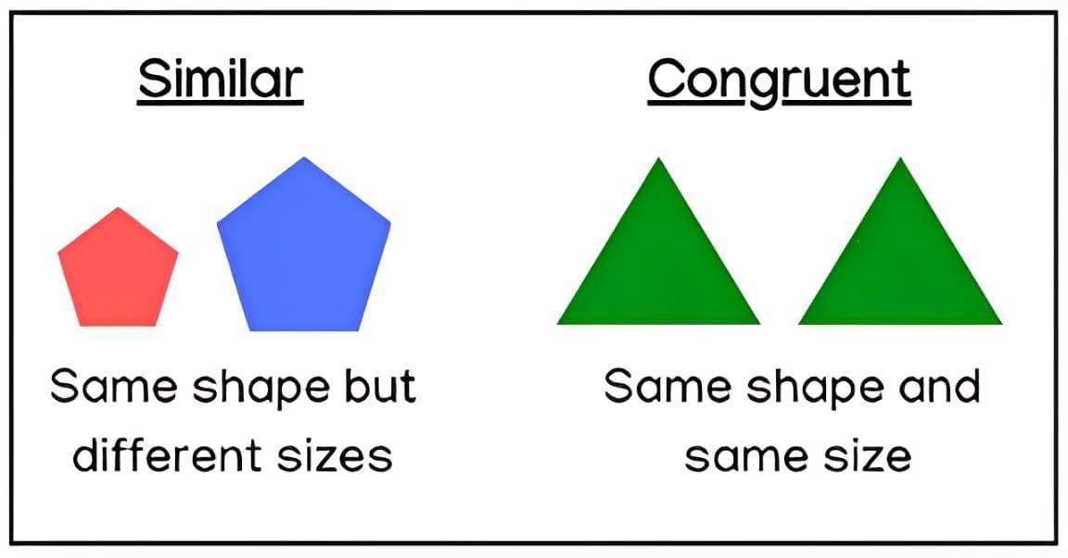
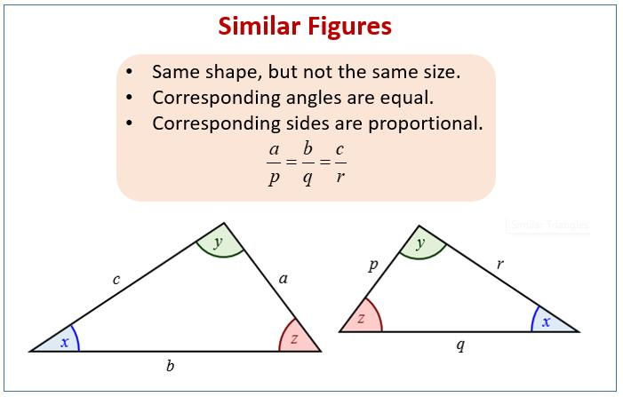
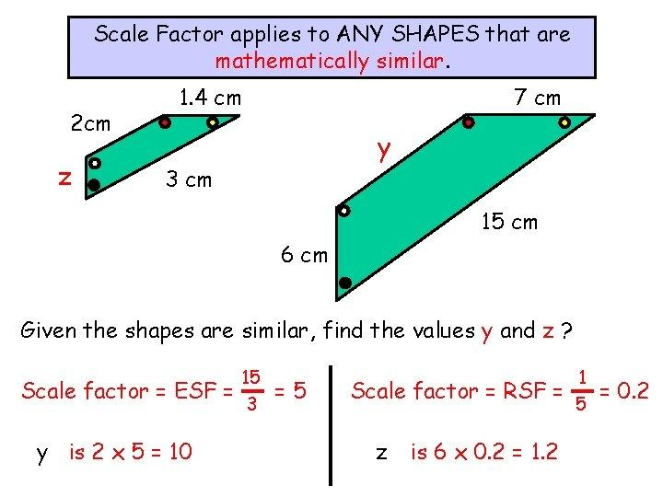
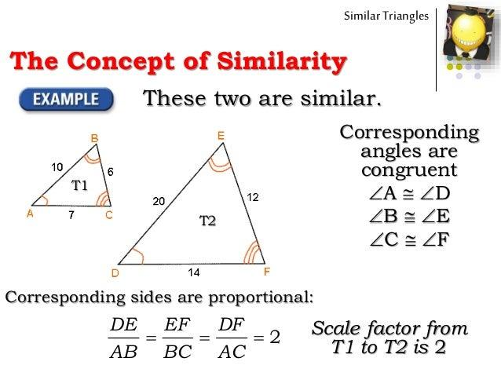
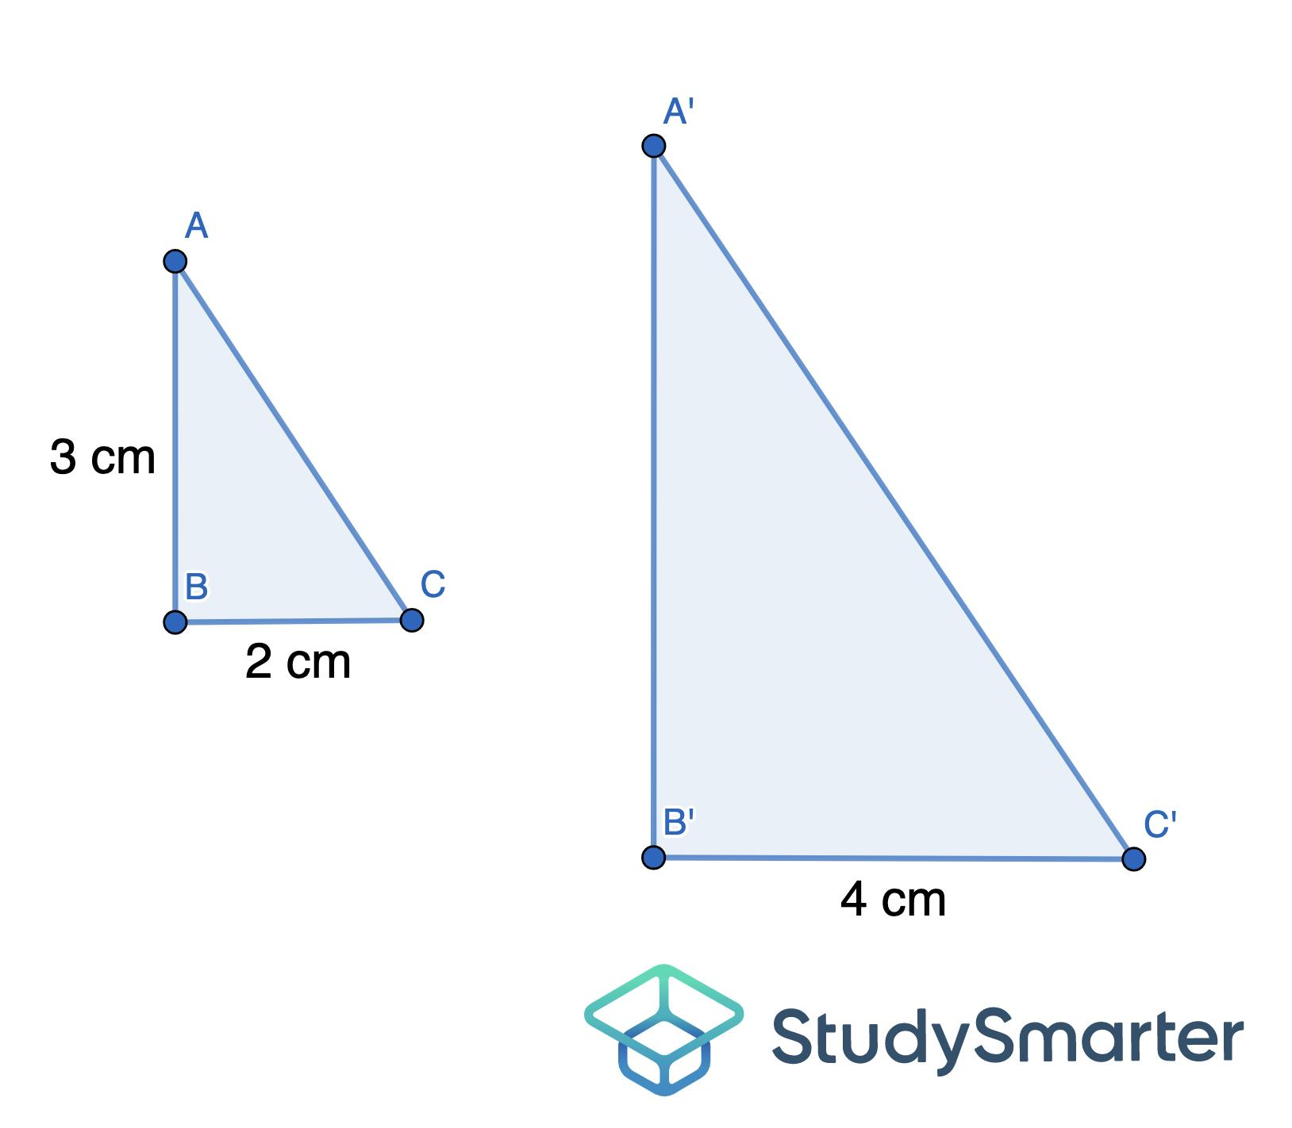
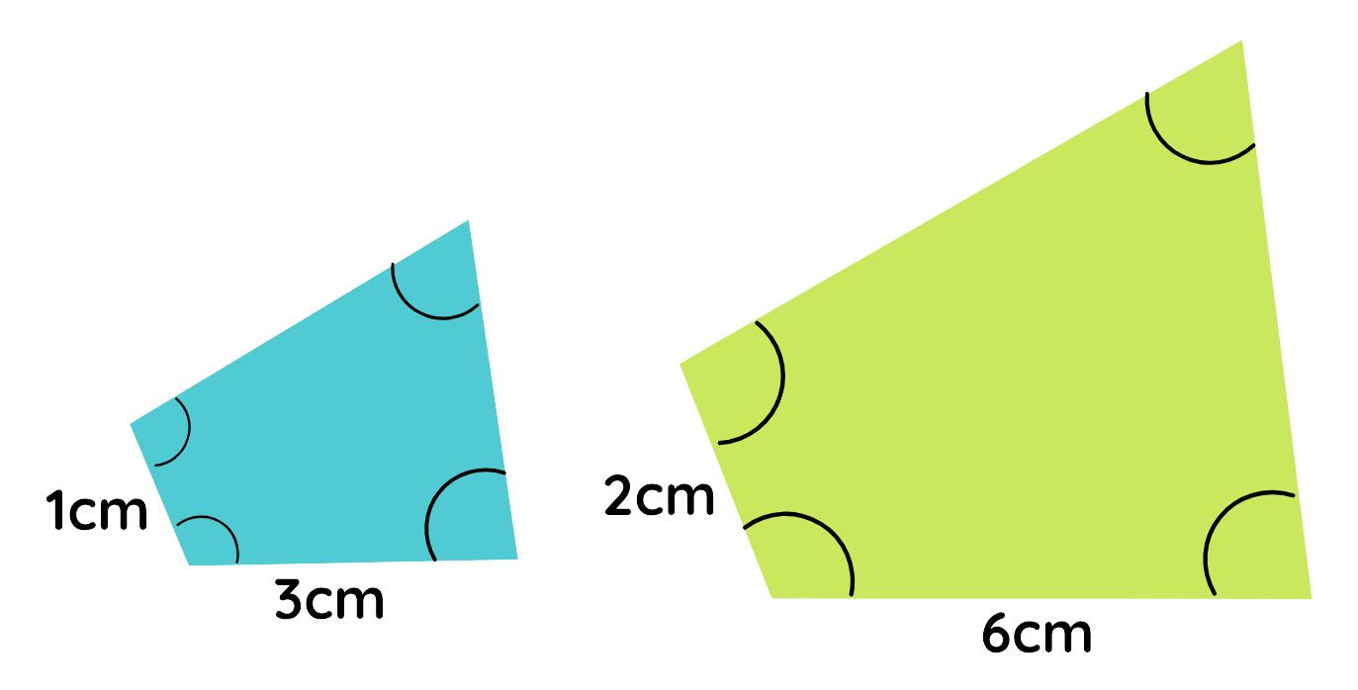

Purpose
# Source: AI Source: Provided by: [Data Path: Persons Table -> ID Column: 1, Name_En Column: Motasem Essam] -> From: [ChatGPT] on [7/25/2026]
Similarity is used to:
- Compare figures with the same shape.
- Determine unknown lengths and angles.
- Calculate distances that are difficult to measure directly.
- Analyze scale drawings and maps.
- Create enlargements and reductions.
- Study proportional relationships.
- Solve geometric problems.
- Support architecture, engineering, surveying, and design.

Fundamental Idea of Similarity
# Source: AI Source: Provided by: [Data Path: Persons Table -> ID Column: 1, Name_En Column: Motasem Essam] -> From: [ChatGPT] on [7/25/2026]
Two figures are similar when:
- Their corresponding angles are equal.
- Their corresponding side lengths are proportional.
- They have the same overall shape.
- Their sizes may be different.
If two figures have a scale factor $k$, then corresponding lengths satisfy:
$$\frac{\text{Corresponding length in image}}{\text{Corresponding length in original}}=k$$
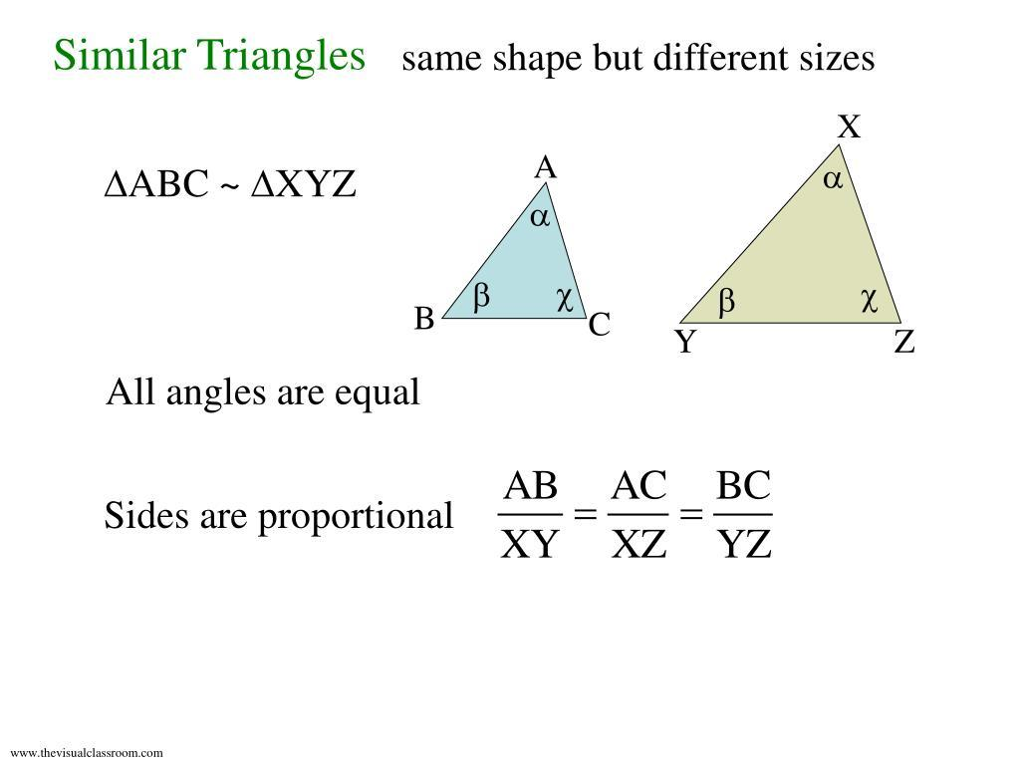
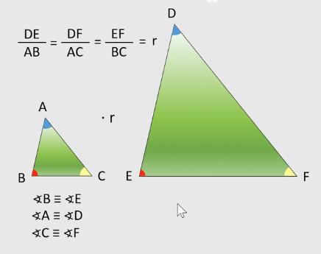
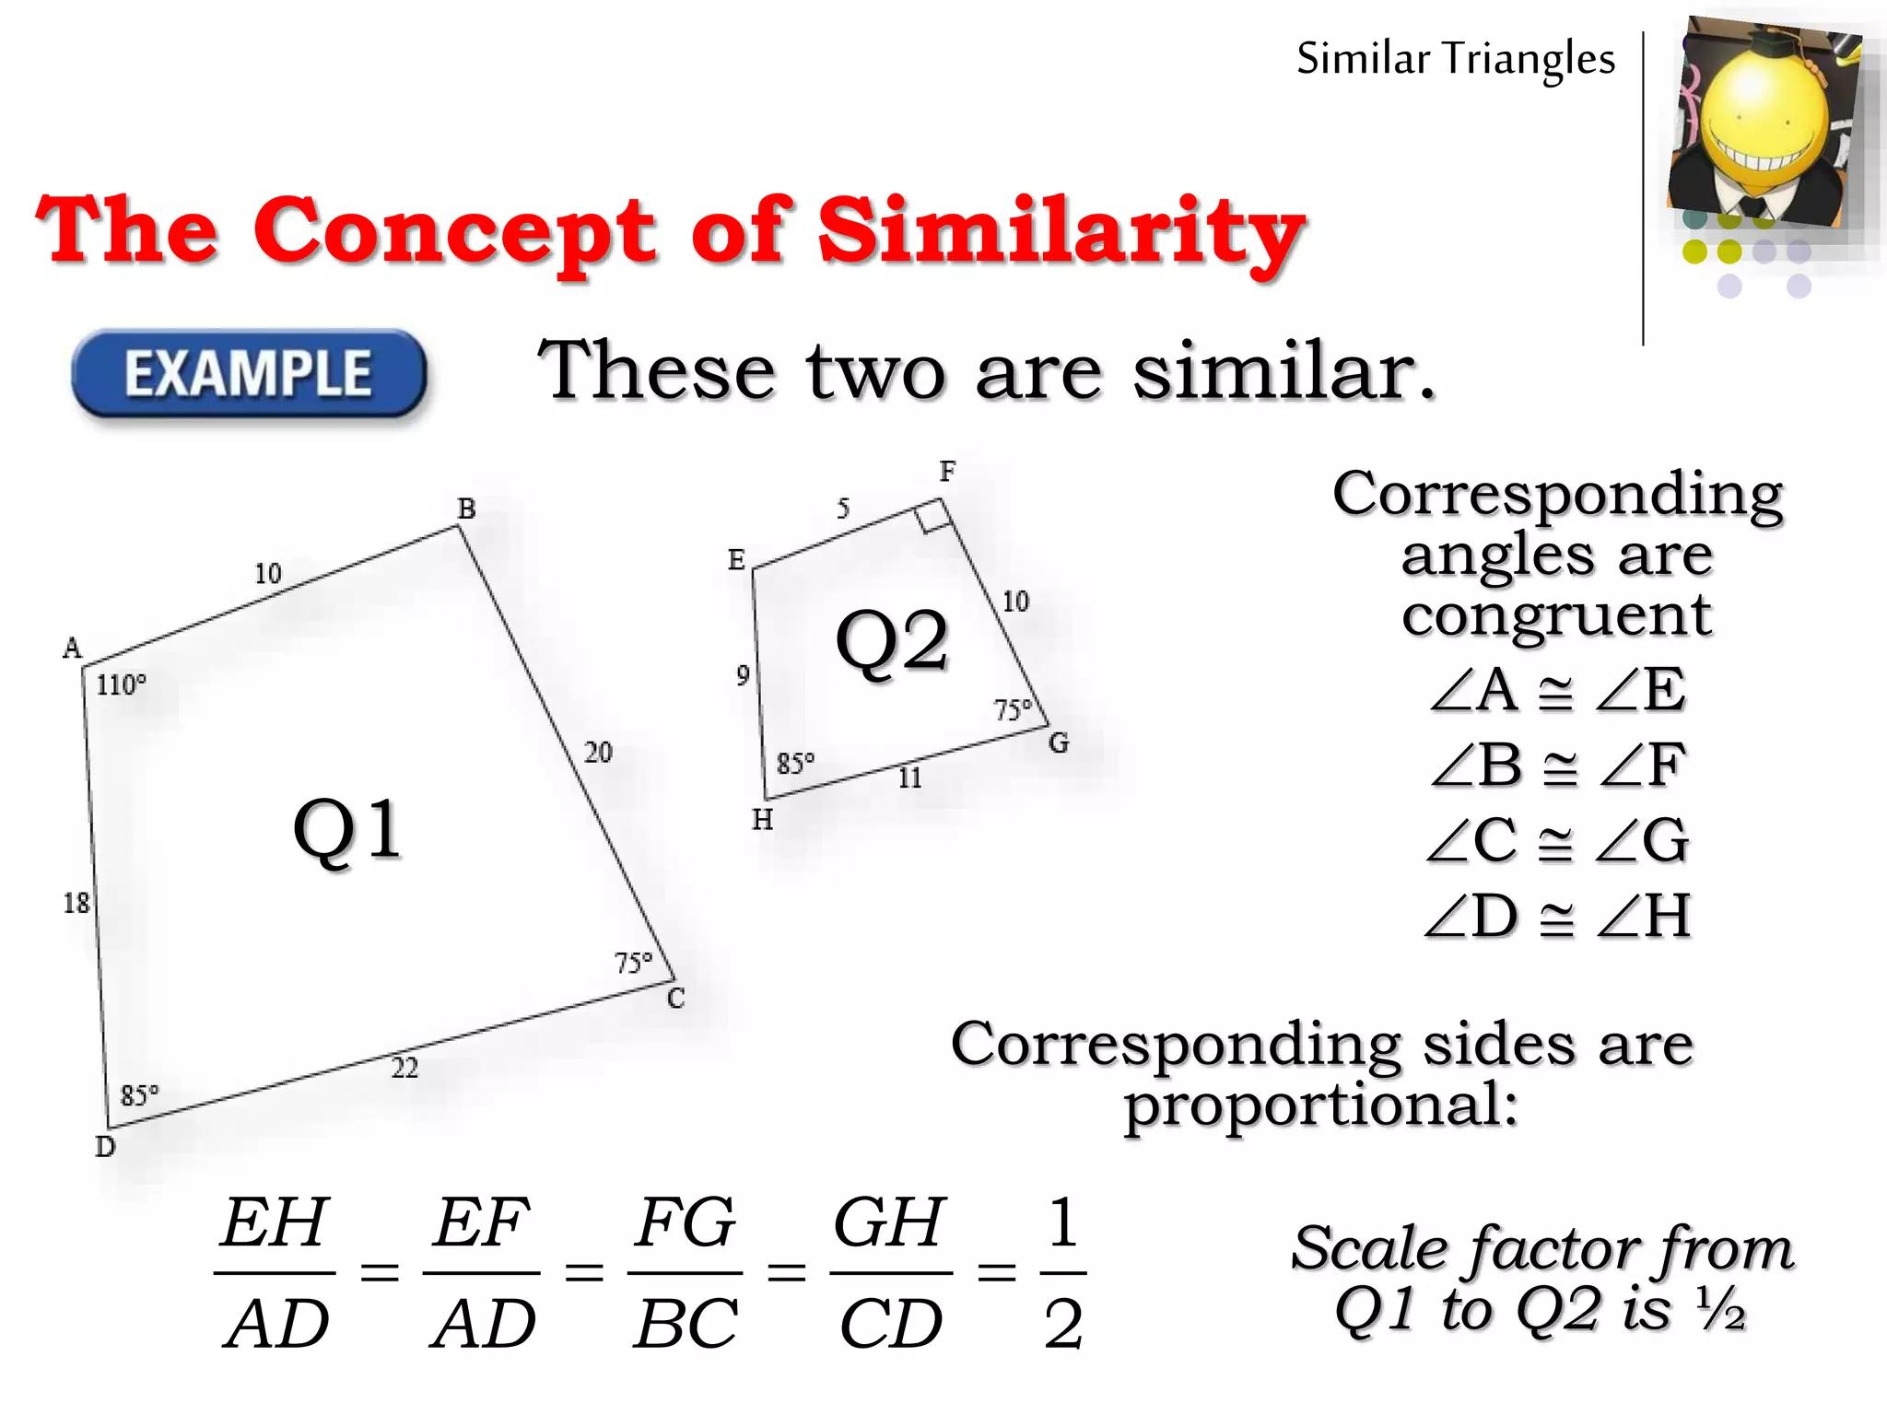
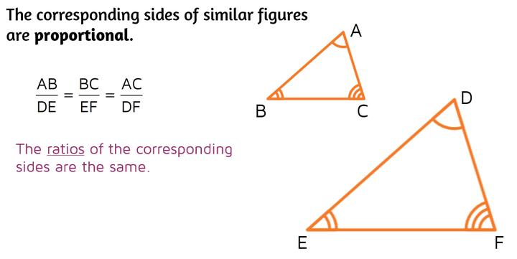

Similar Figures
# Source: AI Source: Provided by: [Data Path: Persons Table -> ID Column: 1, Name_En Column: Motasem Essam] -> From: [ChatGPT] on [7/25/2026]
Definition
Similar figures are geometric figures that have the same shape but may have different sizes.
For example, two rectangles with dimensions:
$$4×6$$
and
$$8×12$$
are similar because:
$$\frac{8}{4}=\frac{12}{6}=2$$
Therefore, their scale factor is:
$$\boxed{k=2}$$
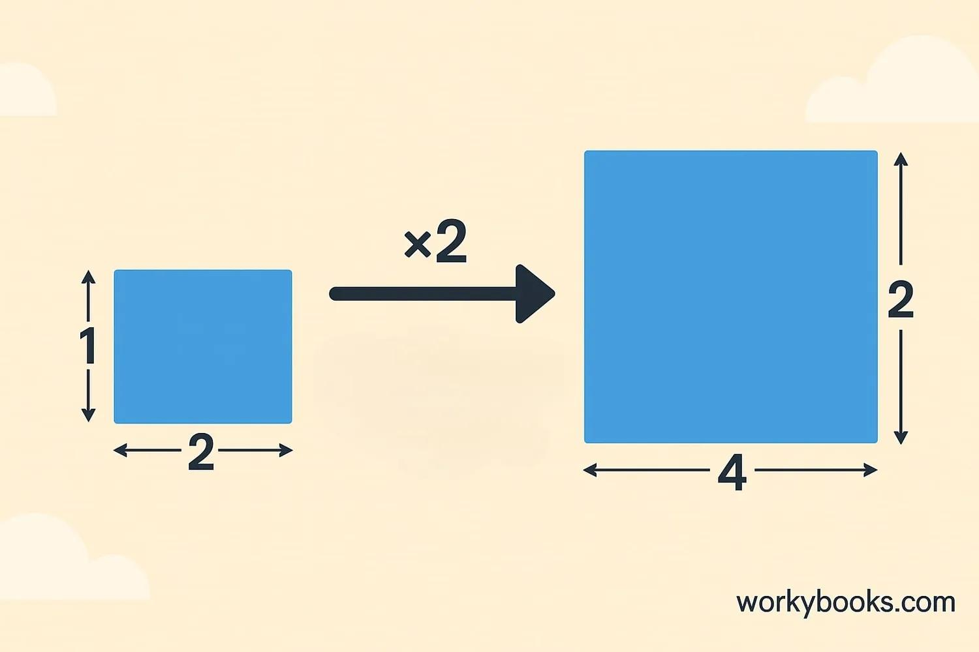
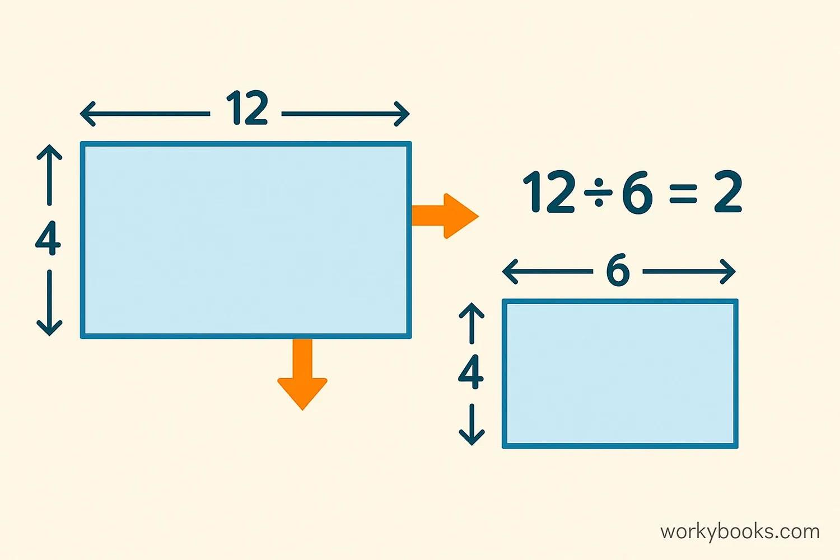
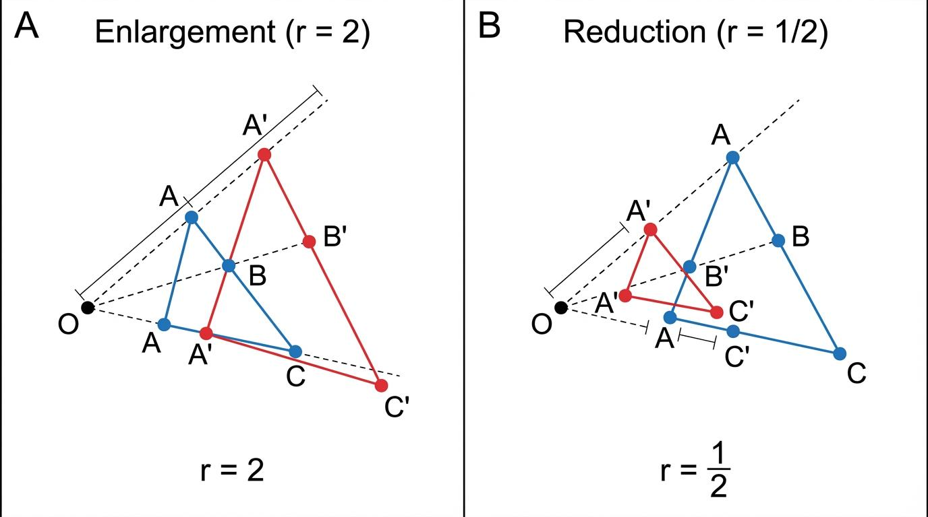
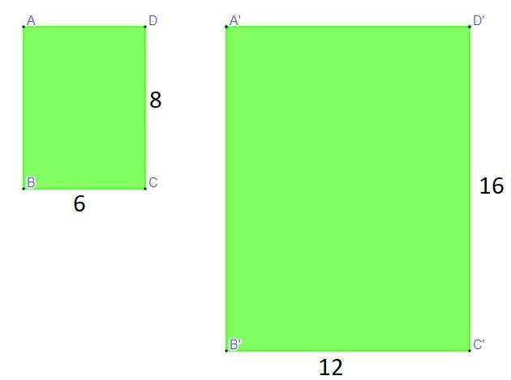
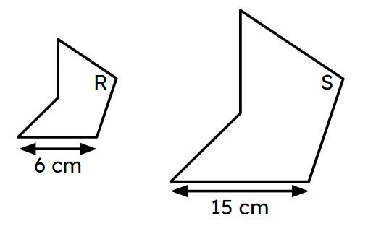

Corresponding Angles
# Source: AI Source: Provided by: [Data Path: Persons Table -> ID Column: 1, Name_En Column: Motasem Essam] -> From: [ChatGPT] on [7/25/2026]
Corresponding angles of similar figures are equal.
If:
$$△ABC∼△DEF$$
then:
$$∠A=∠D \\ ∠B=∠E \\ ∠C=∠F$$
Therefore:
$$\boxed{\text{Corresponding angles are congruent}}$$
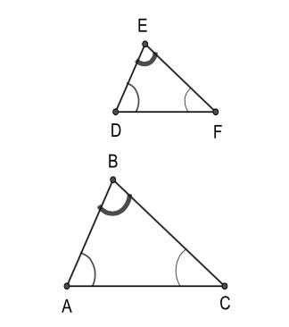
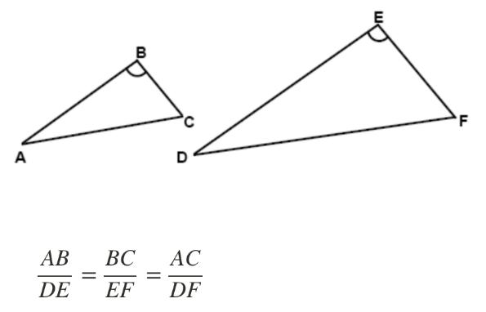
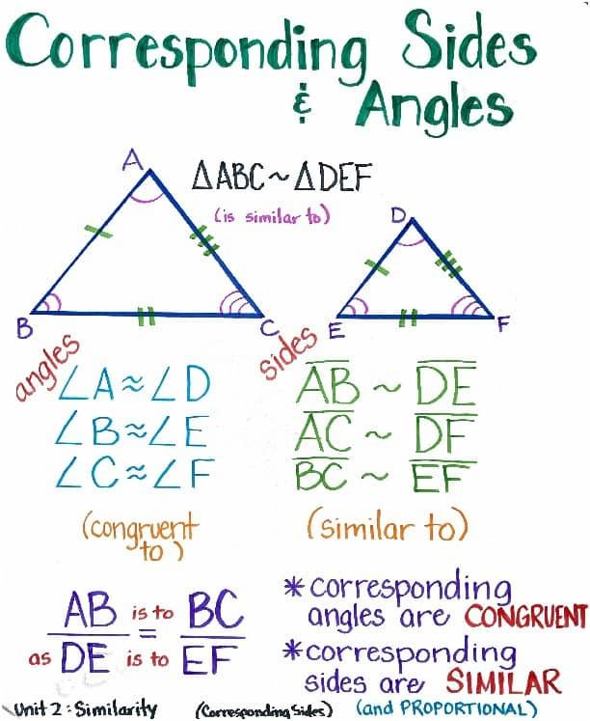
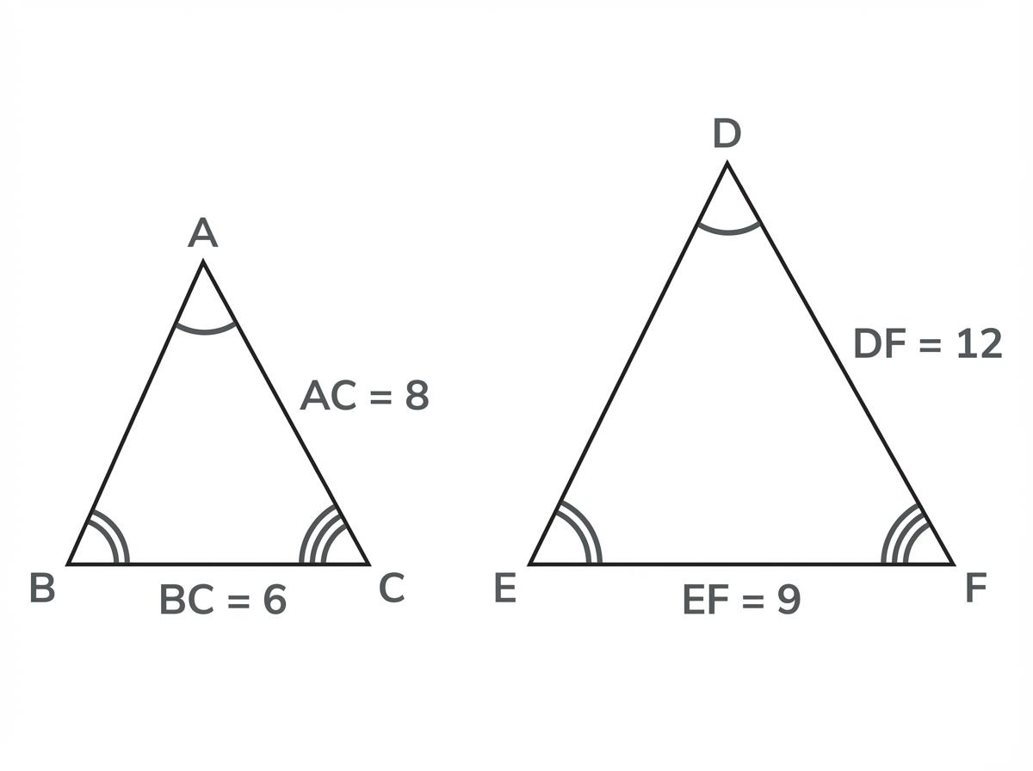
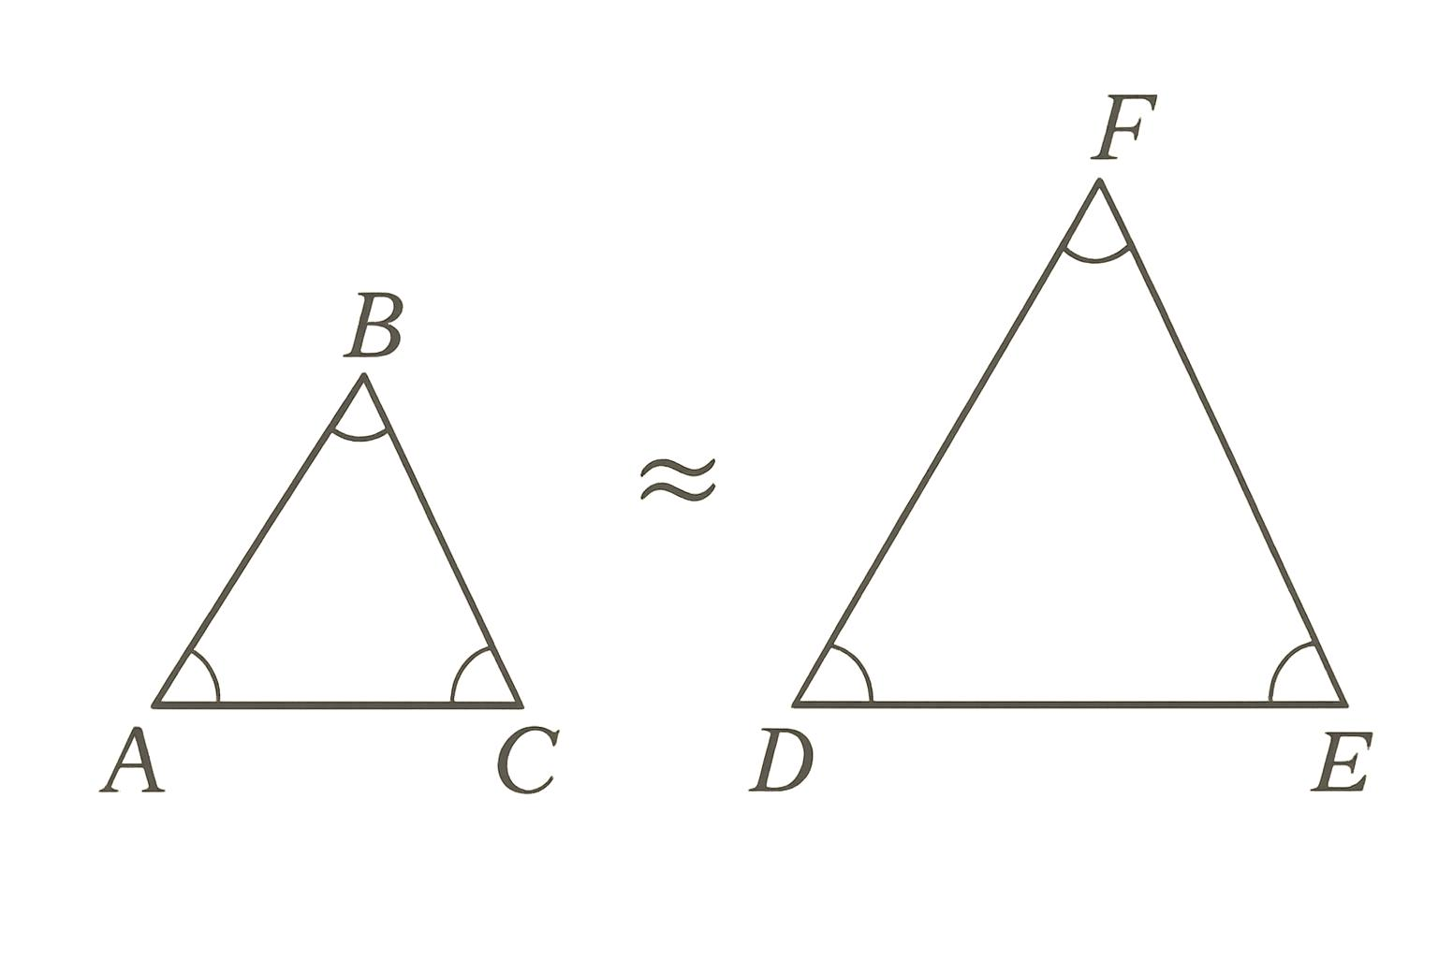

Corresponding Sides
# Source: AI Source: Provided by: [Data Path: Persons Table -> ID Column: 1, Name_En Column: Motasem Essam] -> From: [ChatGPT] on [7/25/2026]
Corresponding sides of similar figures are proportional.
For:
$$△ABC∼△DEF$$
we have:
$$\frac{AB}{DE}=\frac{BC}{EF}=\frac{AC}{DF}$$
The common ratio is called the scale factor.
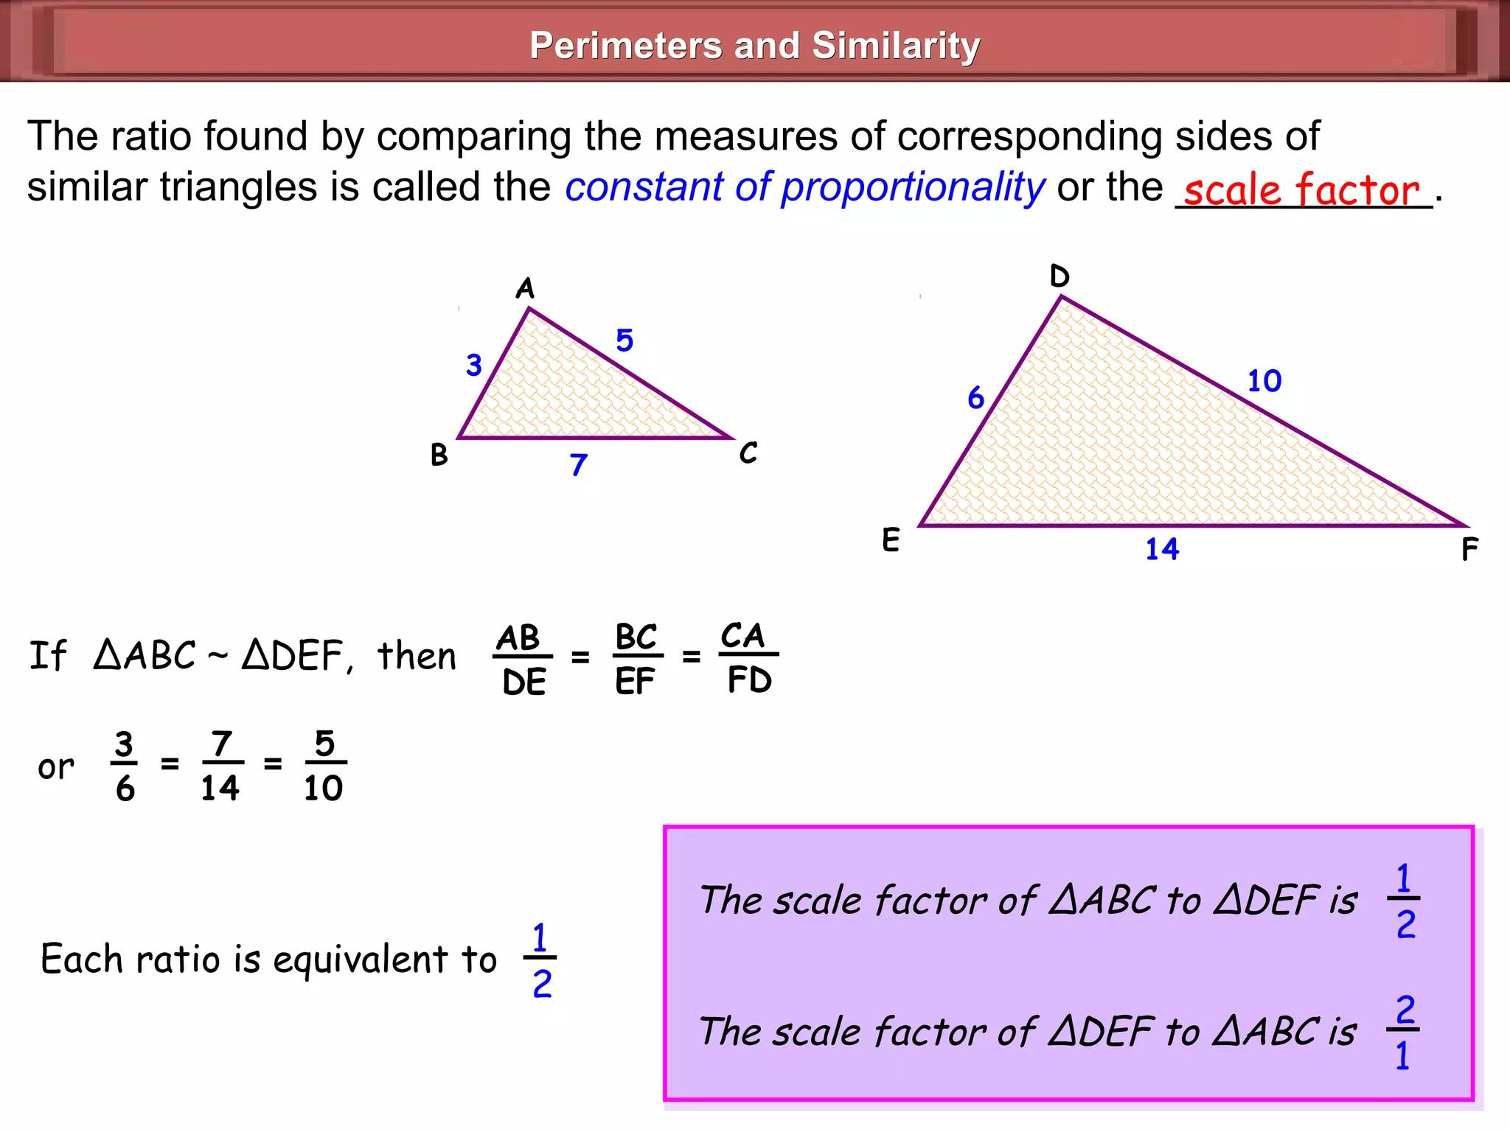
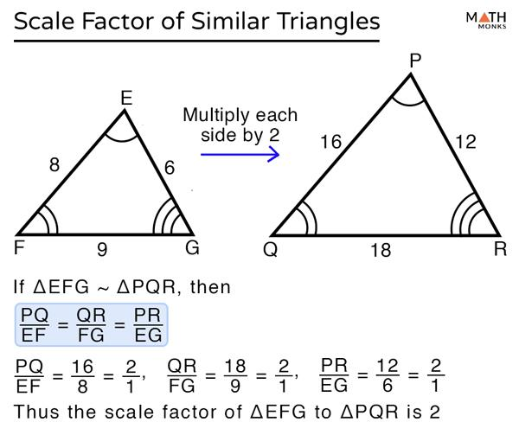
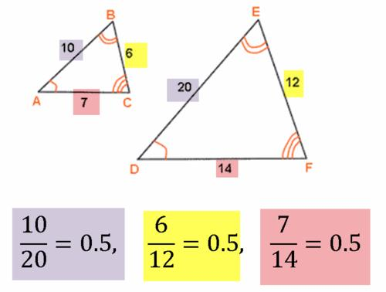
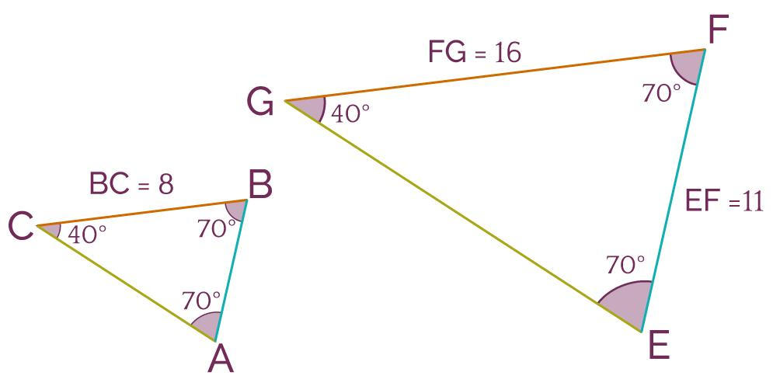

Scale Factor
# Source: AI Source: Provided by: [Data Path: Persons Table -> ID Column: 1, Name_En Column: Motasem Essam] -> From: [ChatGPT] on [7/25/2026]
Definition
The scale factor is the ratio between corresponding lengths of two similar figures.
It can be written as:
$$\boxed{k=\frac{\text{new length}}{\text{original length}}}$$
Enlargement
If:
$$k>1$$
the figure becomes larger.
For example:
$$k=3$$
means every corresponding length is multiplied by $3$.
Reduction
If:
$$0<k<1$$
the figure becomes smaller.
For example:
$$k=\frac{1}{2}$$
means every corresponding length is reduced to half its original size.
Same Size
If:
$$k=1$$
the figures have the same dimensions.
In this case, the figures are also congruent if their shapes correspond.
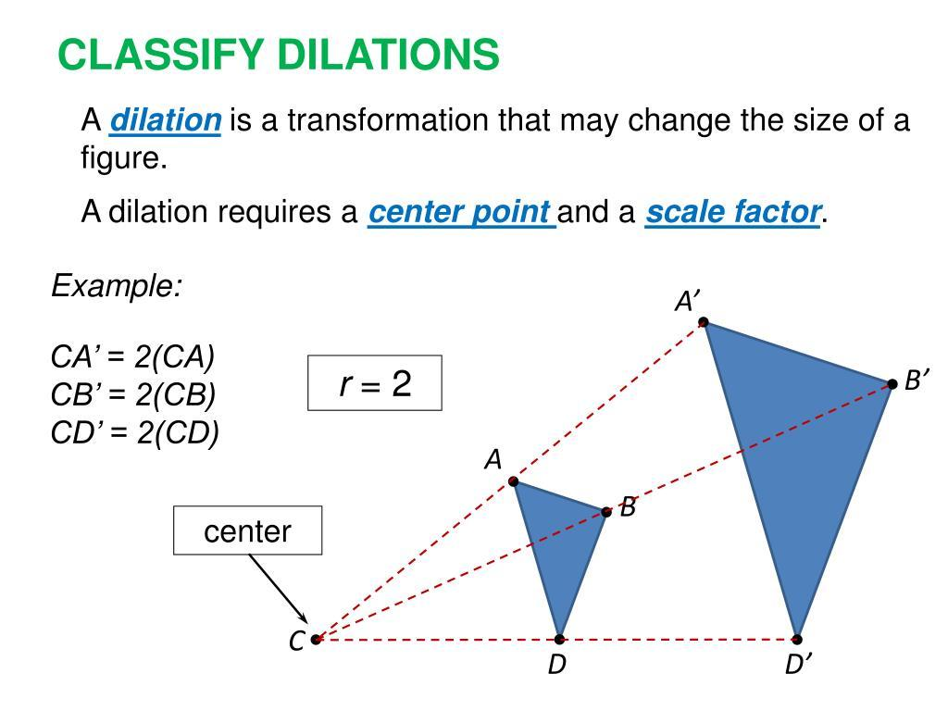
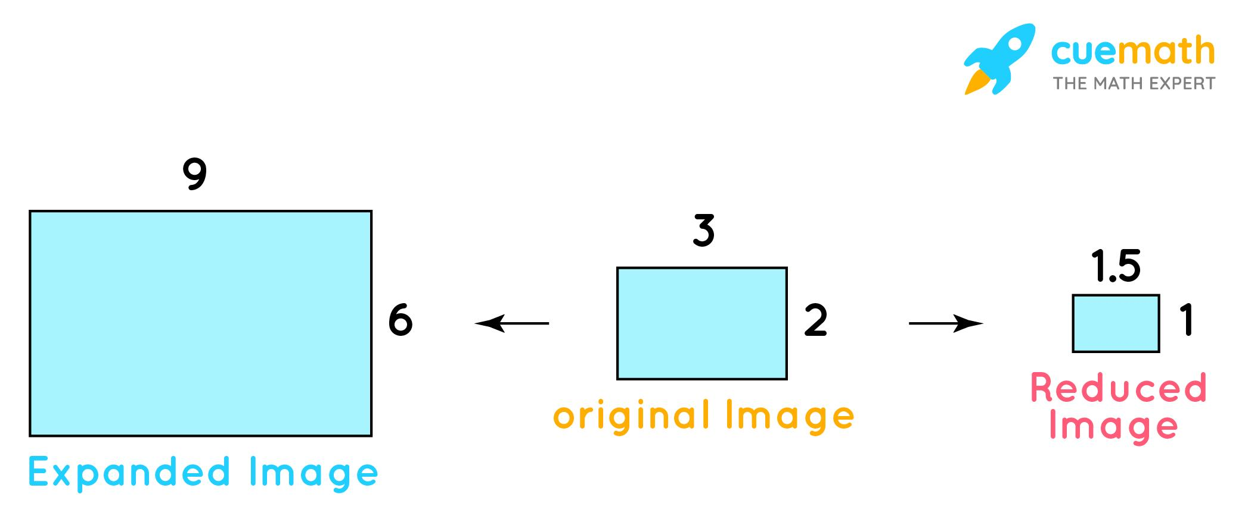
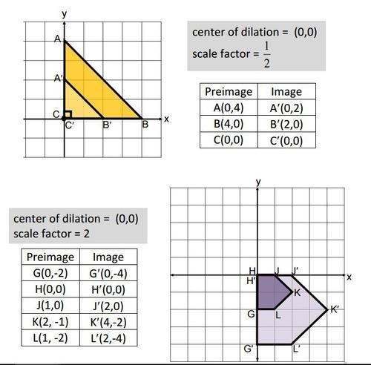

Similarity of Triangles
# Source: AI Source: Provided by: [Data Path: Persons Table -> ID Column: 1, Name_En Column: Motasem Essam] -> From: [ChatGPT] on [7/25/2026]
Triangles are similar when their corresponding angles are equal and their corresponding sides are proportional.
There are three major criteria for proving triangle similarity.

1. AA — Angle-Angle
# Source: AI Source: Provided by: [Data Path: Persons Table -> ID Column: 1, Name_En Column: Motasem Essam] -> From: [ChatGPT] on [7/25/2026]
Two triangles are similar if two corresponding angles are equal.
$$\boxed{AA}$$
If:
$$∠A=∠D$$
and
$$∠B=∠E$$
then:
$$△ABC∼△DEF$$
The third pair of angles must also be equal because the angle sum of a triangle is ${180}^{∘}$.
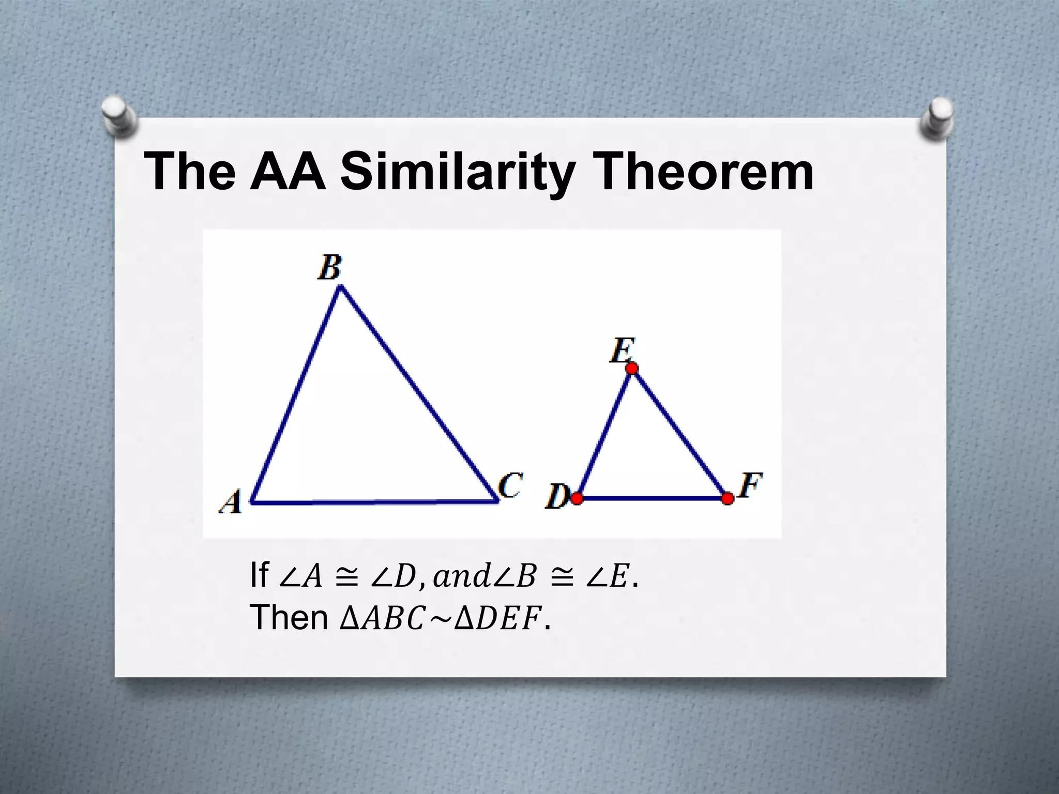
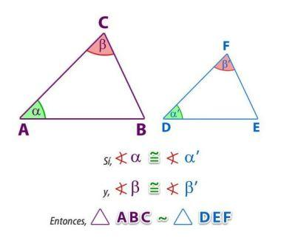
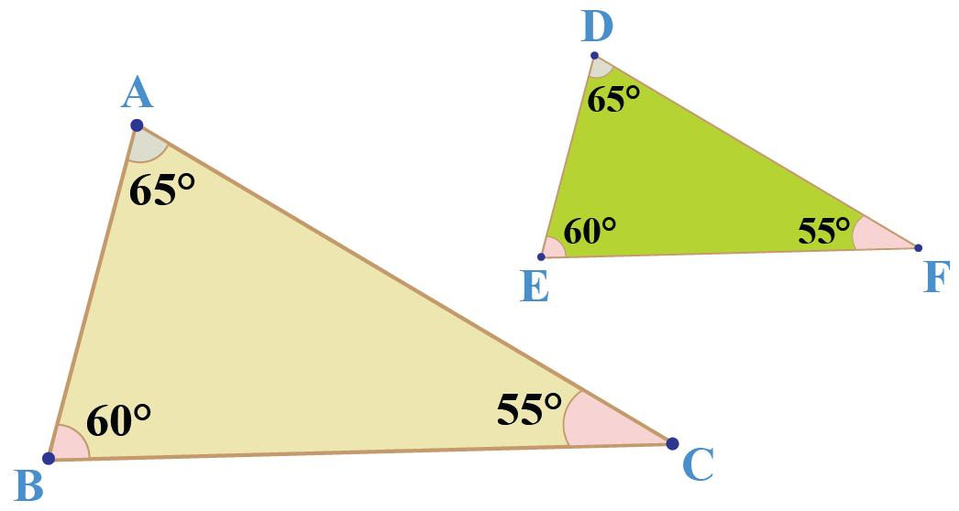
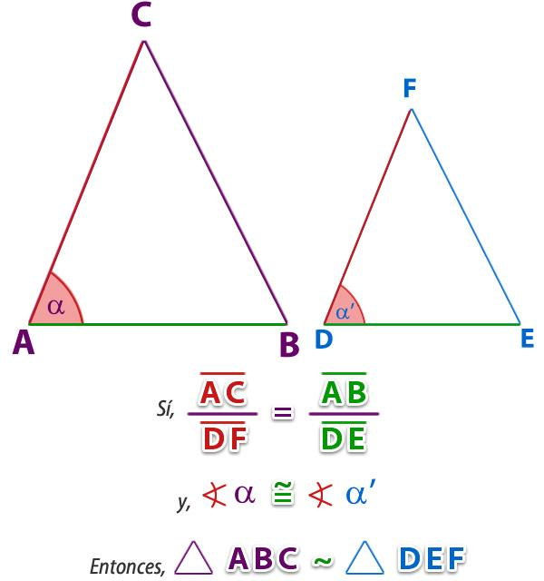
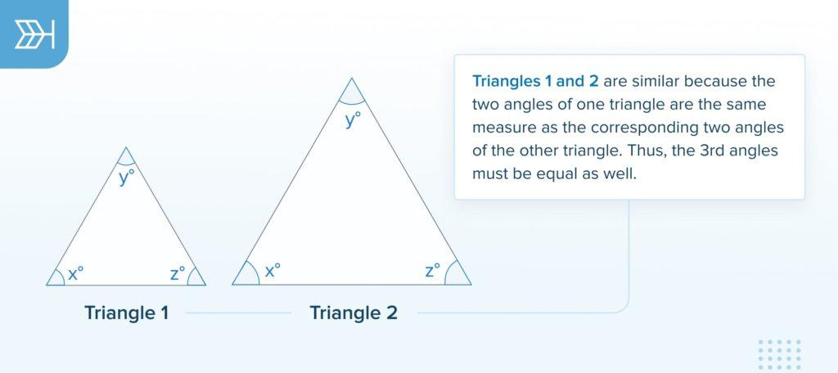
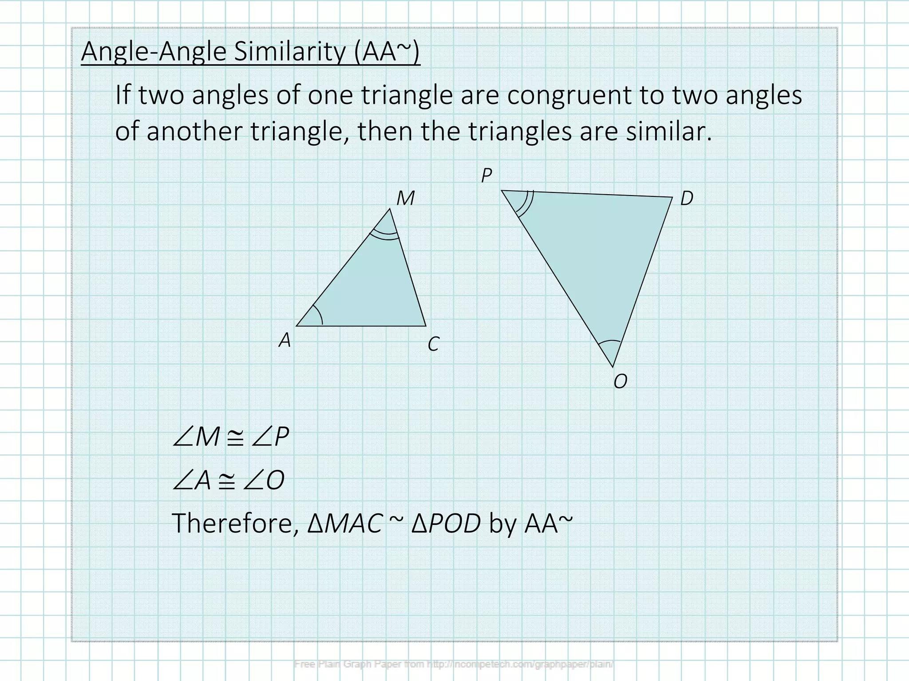

2. SSS — Side-Side-Side
# Source: AI Source: Provided by: [Data Path: Persons Table -> ID Column: 1, Name_En Column: Motasem Essam] -> From: [ChatGPT] on [7/25/2026]
Two triangles are similar if all three pairs of corresponding sides are proportional.
$$\boxed{SSS}$$
For example:
$$\frac{AB}{DE}=\frac{BC}{EF}=\frac{AC}{DF}$$
Therefore:
$$△ABC∼△DEF$$
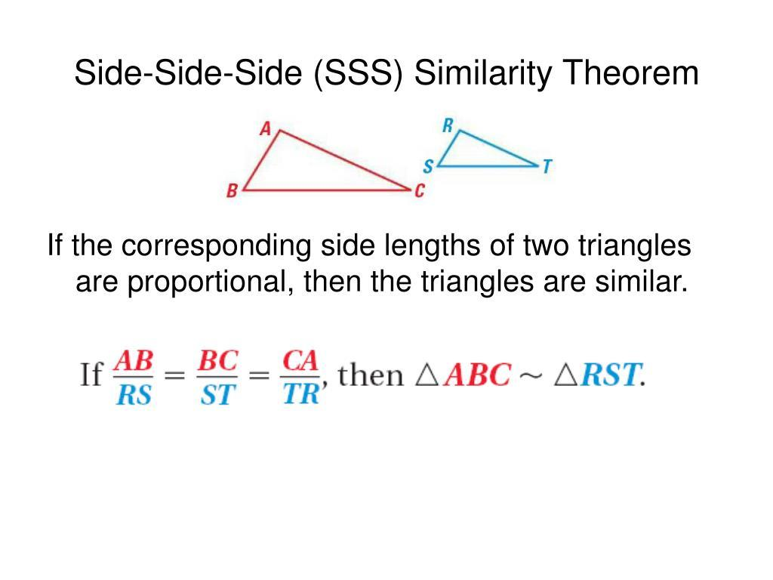
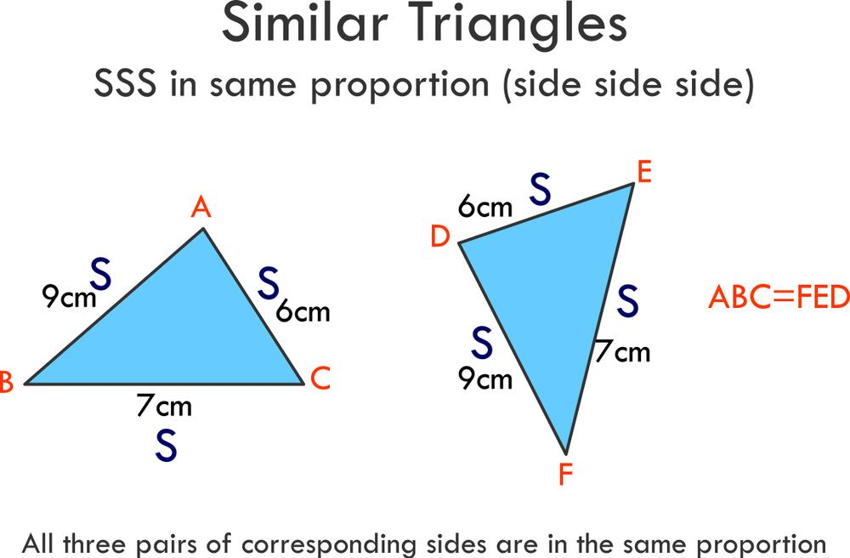
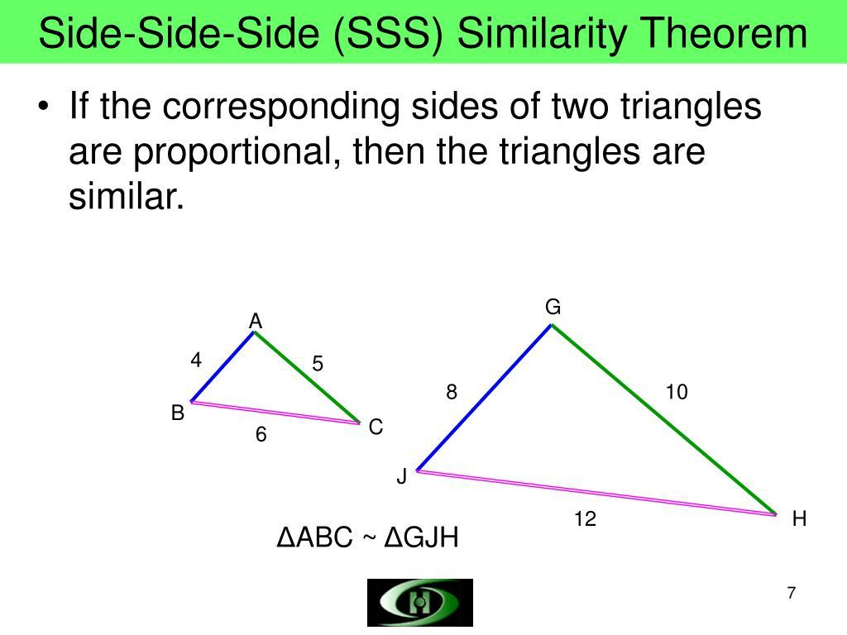
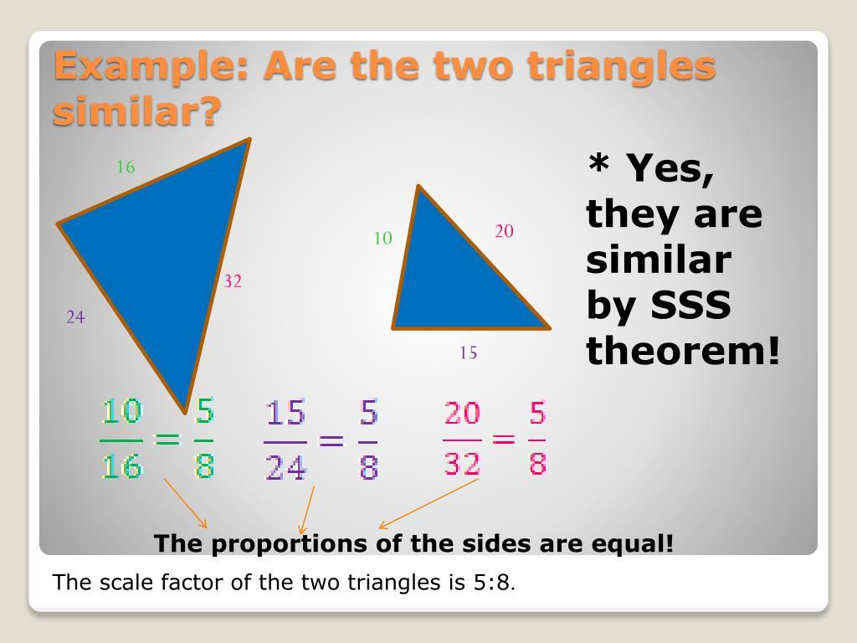
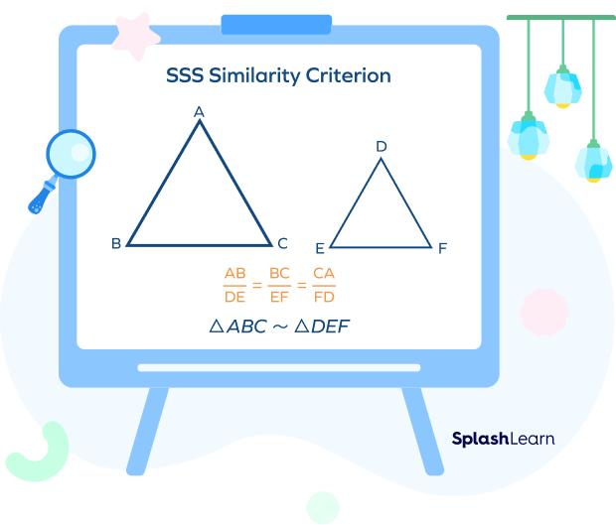

3. SAS — Side-Angle-Side
# Source: AI Source: Provided by: [Data Path: Persons Table -> ID Column: 1, Name_En Column: Motasem Essam] -> From: [ChatGPT] on [7/25/2026]
Two triangles are similar if two corresponding sides are proportional and their included angles are equal.
$$\boxed{SAS}$$
For example:
$$\frac{AB}{DE}=\frac{AC}{DF}$$
and:
$$∠A=∠D$$
Therefore:
$$△ABC∼△DEF$$
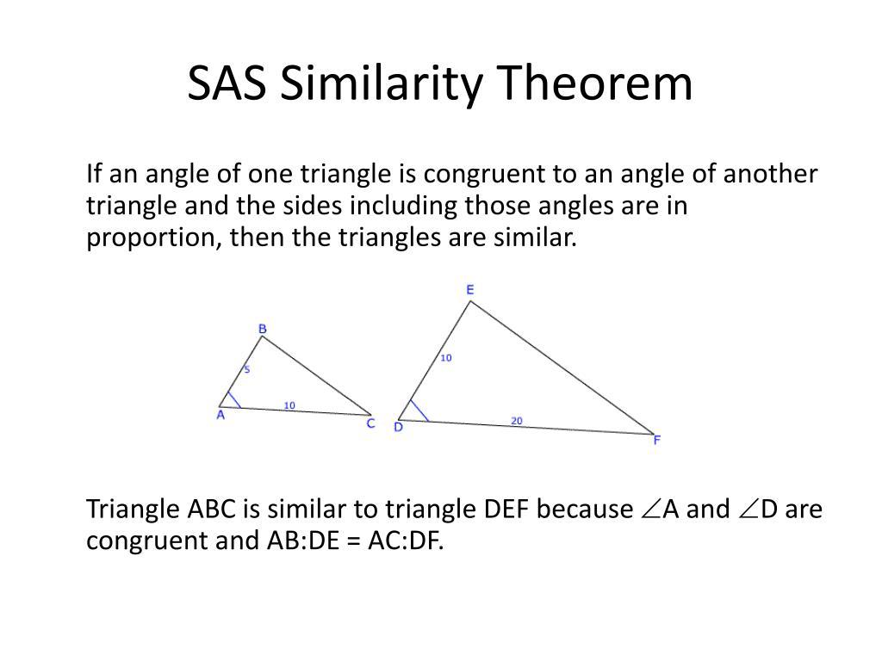
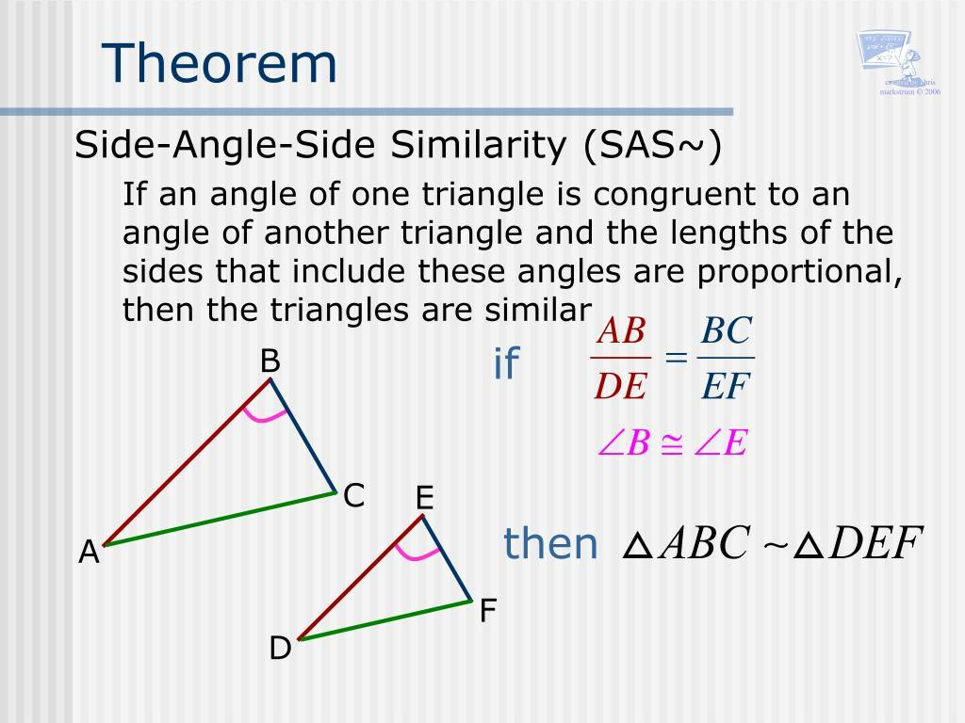
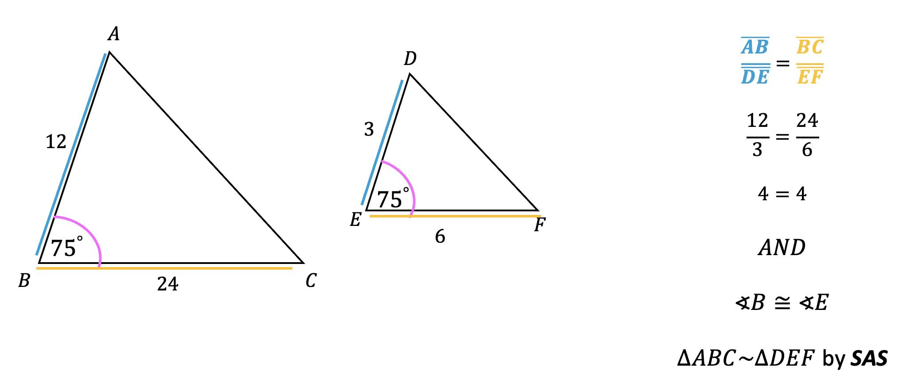
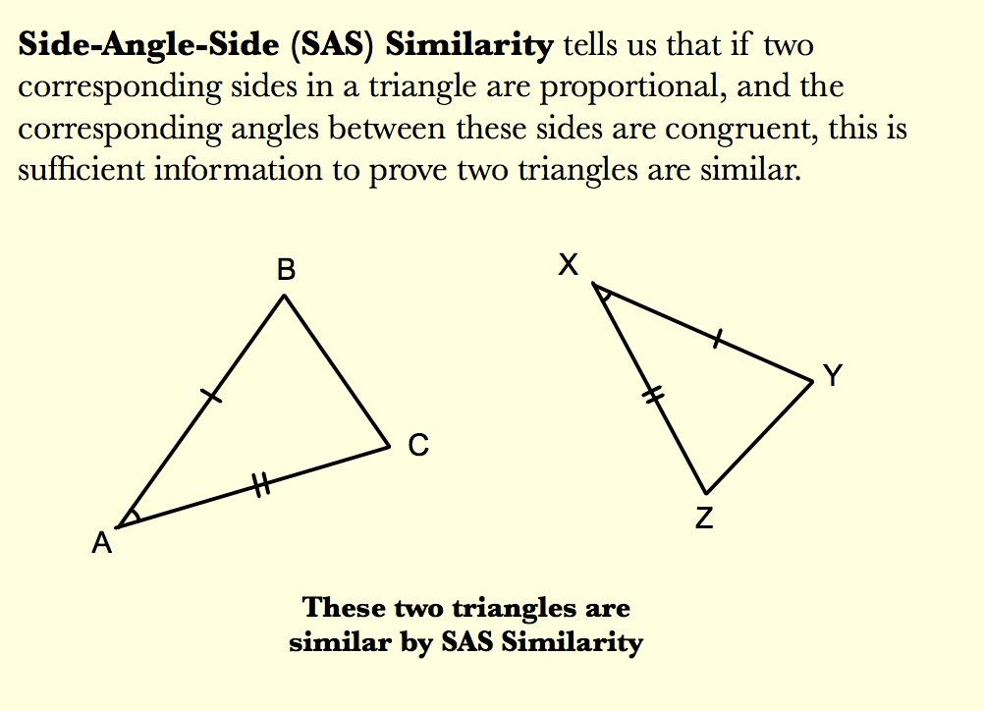
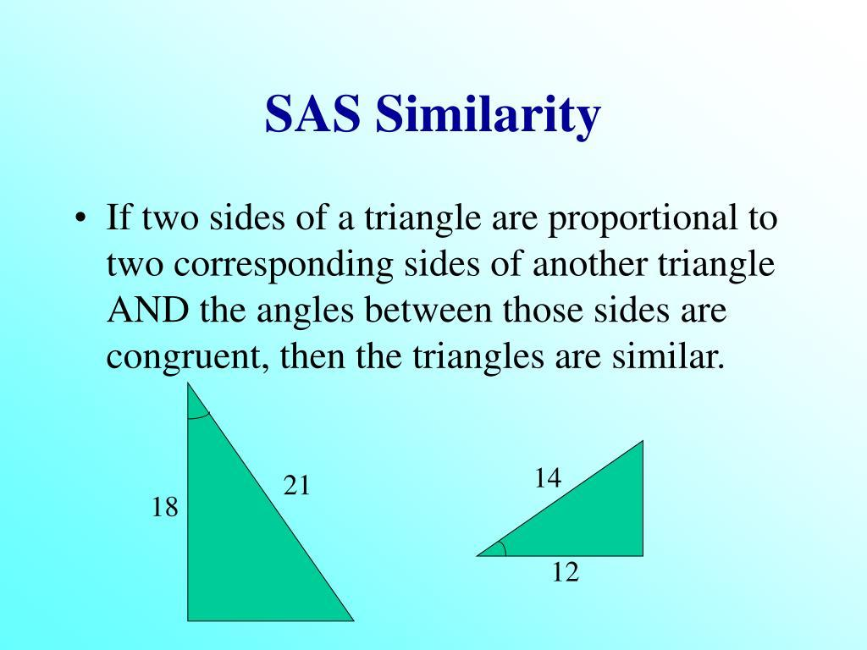

Similarity and Dilation
# Source: AI Source: Provided by: [Data Path: Persons Table -> ID Column: 1, Name_En Column: Motasem Essam] -> From: [ChatGPT] on [7/25/2026]
Dilation is one of the most important transformations associated with similarity.
A dilation enlarges or reduces a figure while preserving its shape.
For a dilation centered at the origin:
$$\boxed{\left(x,y\right)→\left(kx,ky\right)}$$
where $k$ is the scale factor.
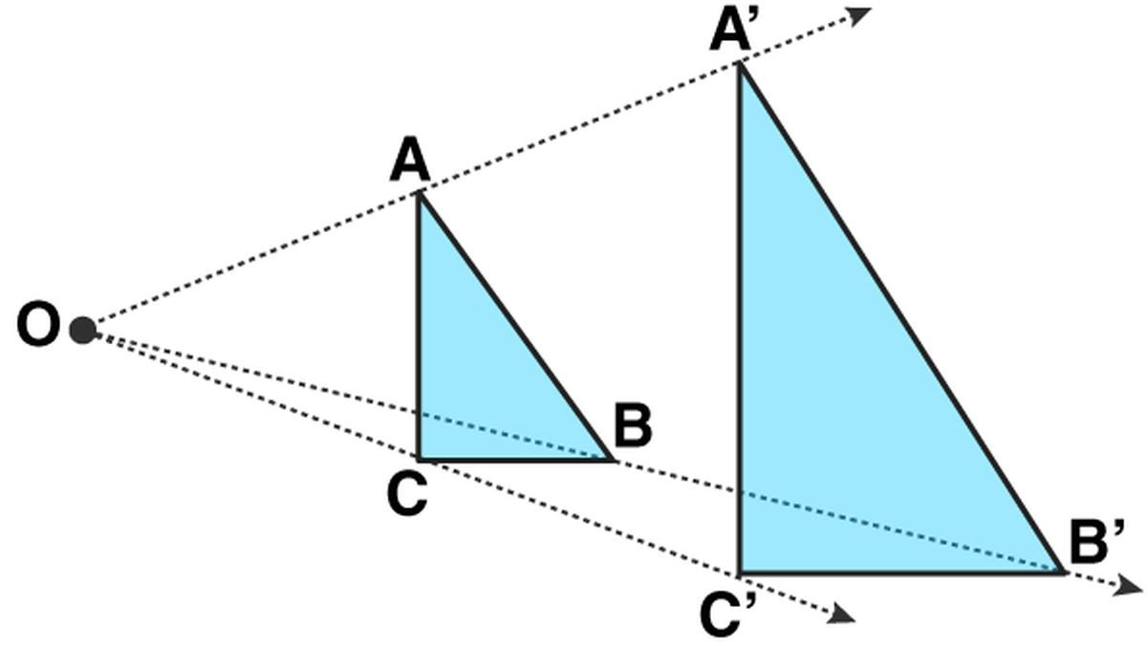
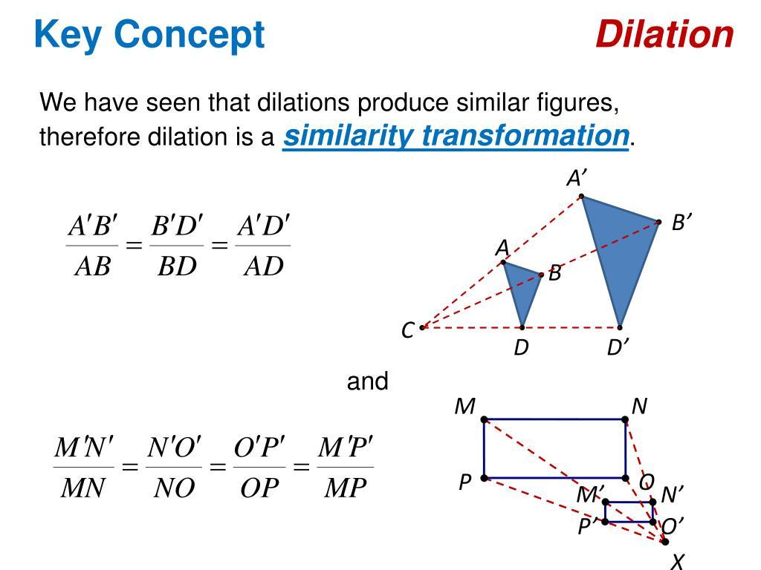
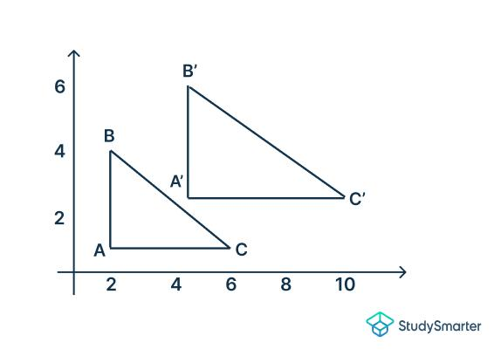
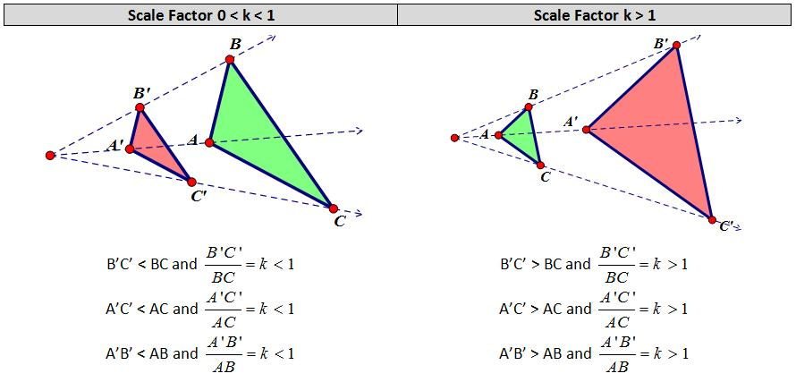
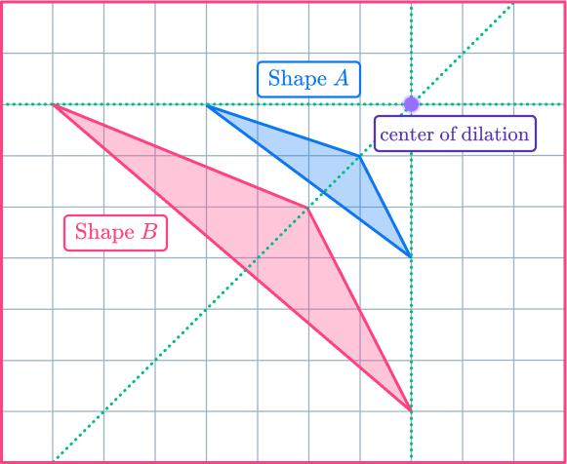
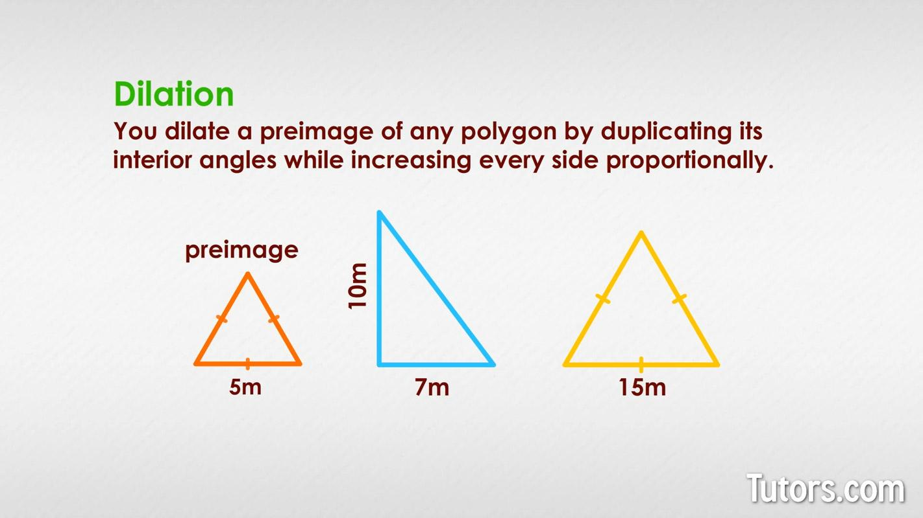
Therefore:
$$\boxed{\text{Dilation}⇒\text{Similar Figure}}$$
when the scale factor changes the size.

Similarity and Area
# Source: AI Source: Provided by: [Data Path: Persons Table -> ID Column: 1, Name_En Column: Motasem Essam] -> From: [ChatGPT] on [7/25/2026]
If two similar figures have a linear scale factor:
$$k$$
then their areas have a scale factor of:
$$\boxed{k^{2}}$$
For example, if:
$$k=2$$
then:
$$\frac{A_{2}}{A_{1}}=2^{2}=4$$
So the larger figure has 4 times the area.
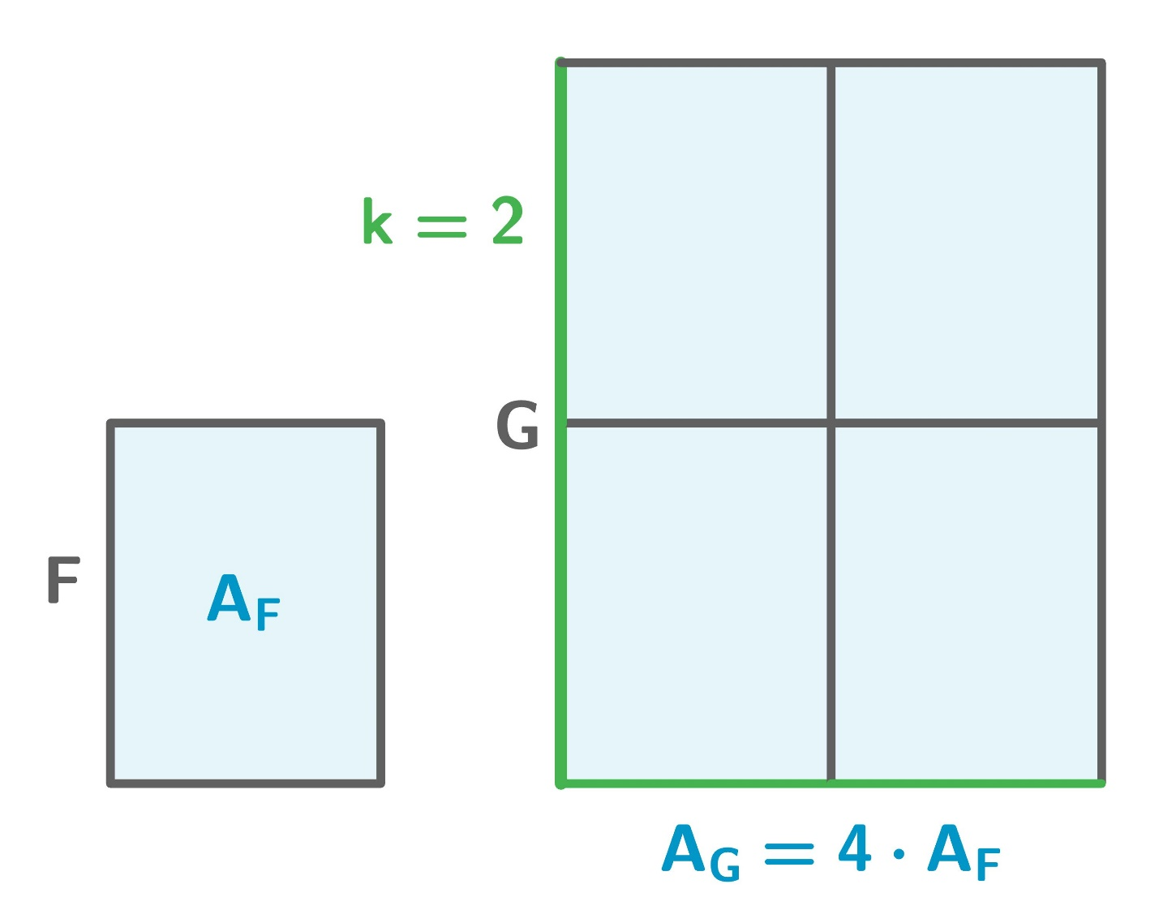
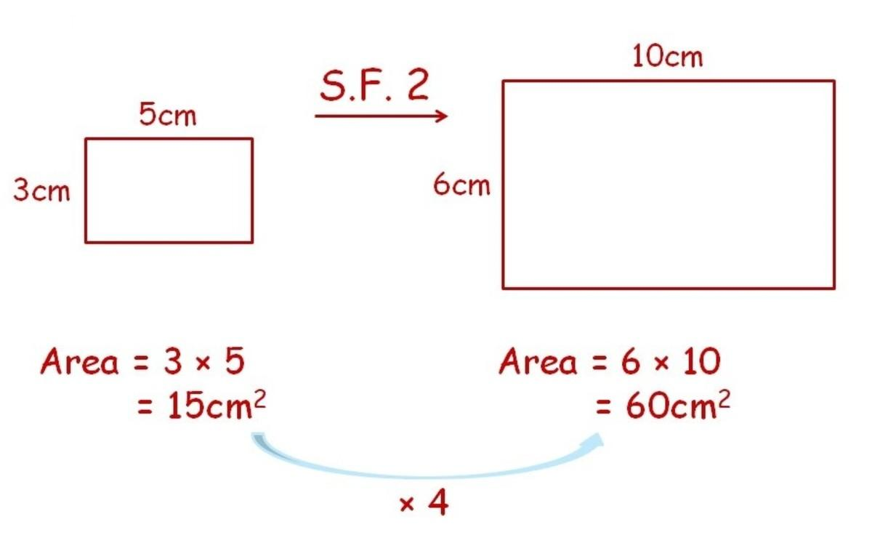
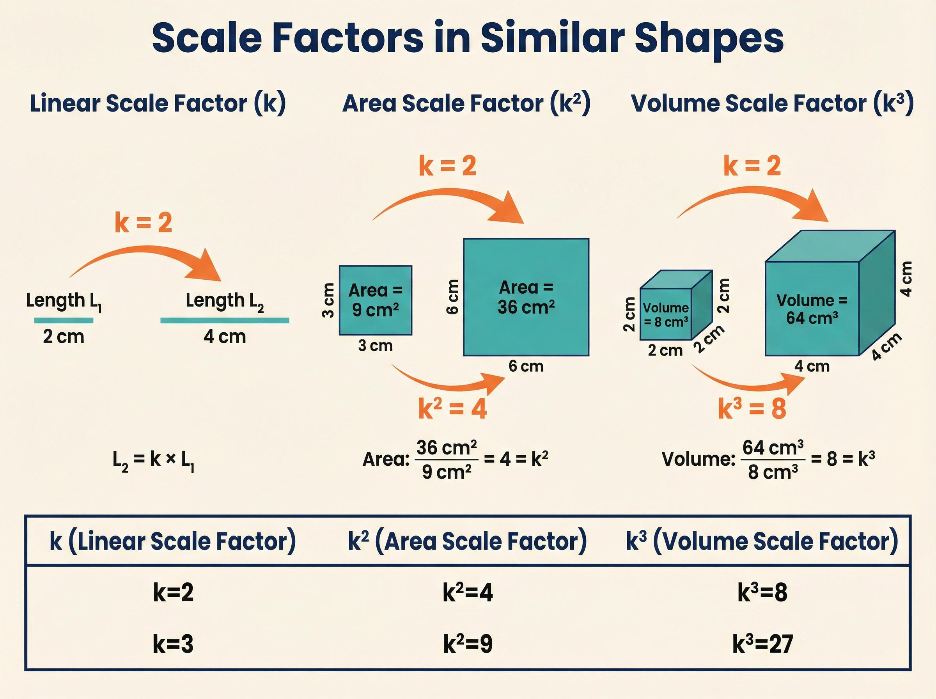
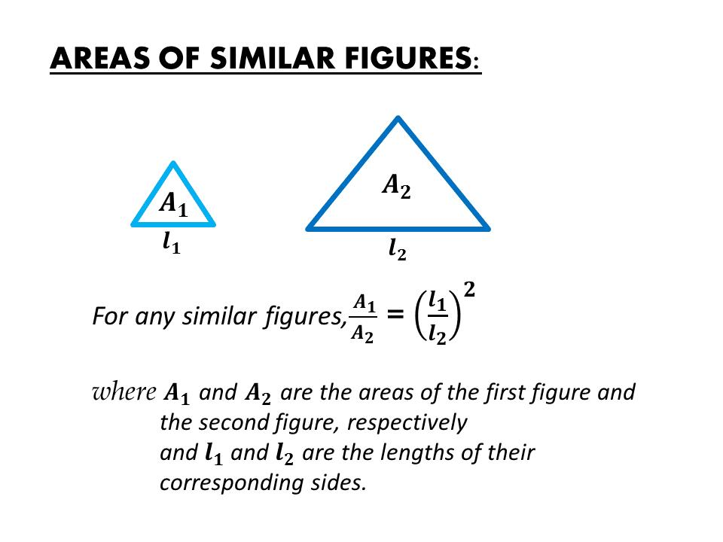
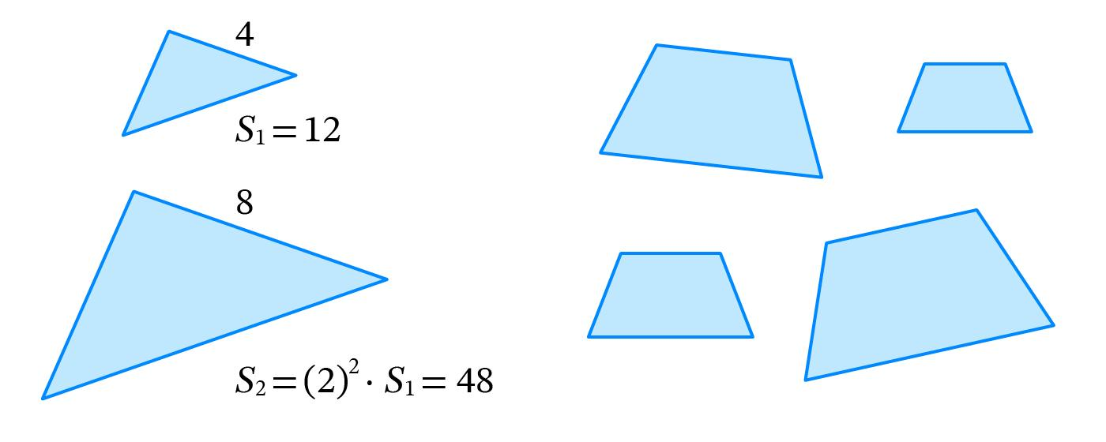
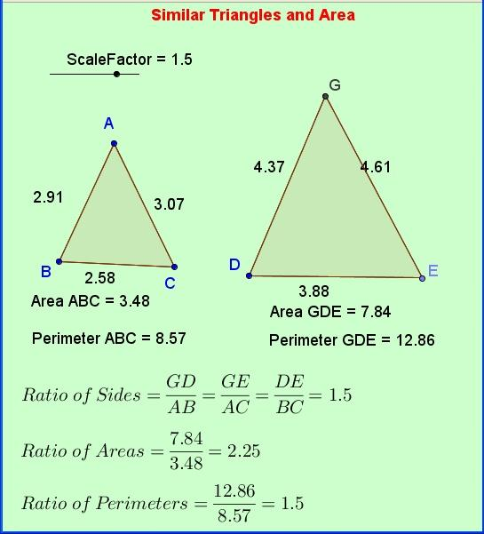

Similarity and Perimeter
# Source: AI Source: Provided by: [Data Path: Persons Table -> ID Column: 1, Name_En Column: Motasem Essam] -> From: [ChatGPT] on [7/25/2026]
For similar figures, the ratio of their perimeters is equal to the linear scale factor.
If:
$$k=3$$
then:
$$\frac{P_{2}}{P_{1}}=3$$
Therefore:
$$\boxed{\text{Perimeter Scale Factor}=k}$$

Similarity and Volume
# Source: AI Source: Provided by: [Data Path: Persons Table -> ID Column: 1, Name_En Column: Motasem Essam] -> From: [ChatGPT] on [7/25/2026]
For similar three-dimensional figures, if the linear scale factor is:
$$k$$
then the volume scale factor is:
$$\boxed{k^{3}}$$
For example, if:
$$k=2$$
then:
$$\frac{V_{2}}{V_{1}}=2^{3}=8$$
The larger solid has 8 times the volume.
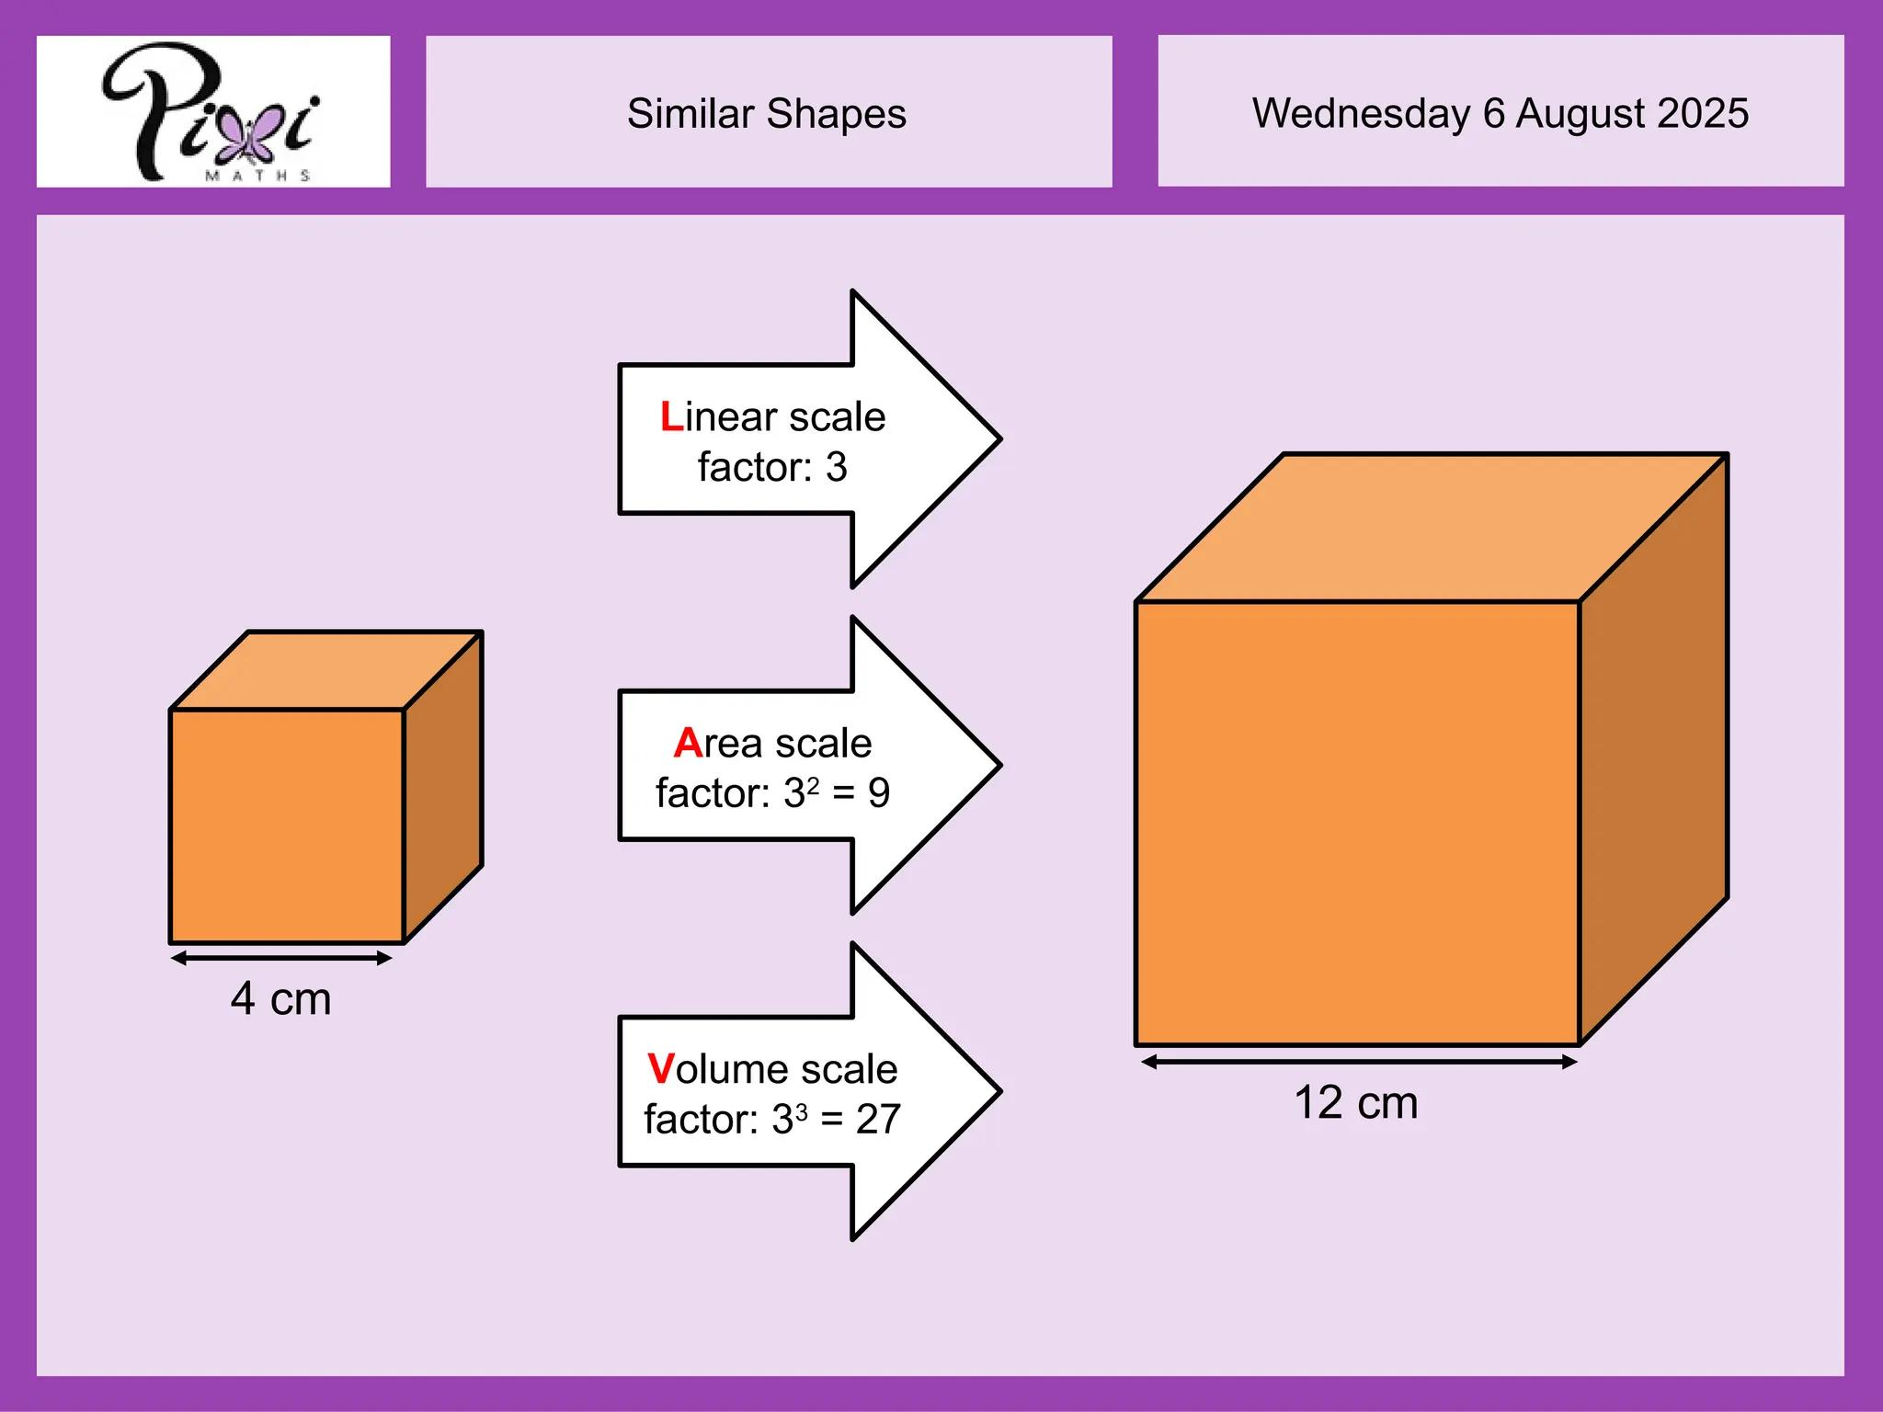
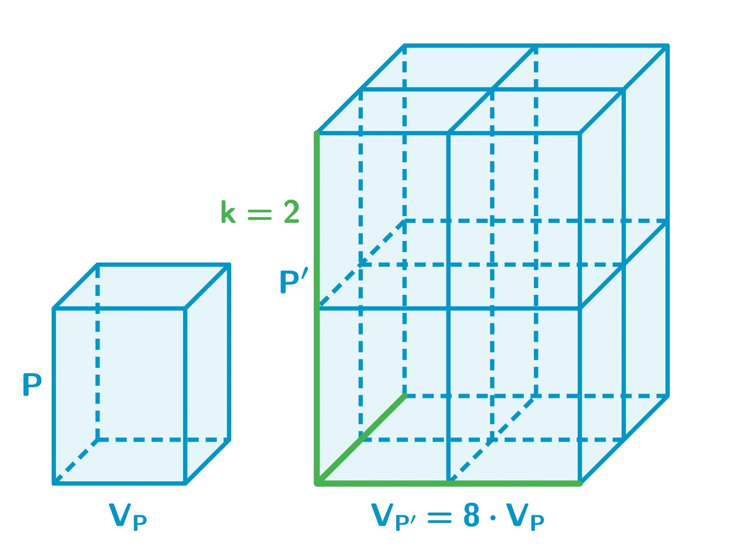
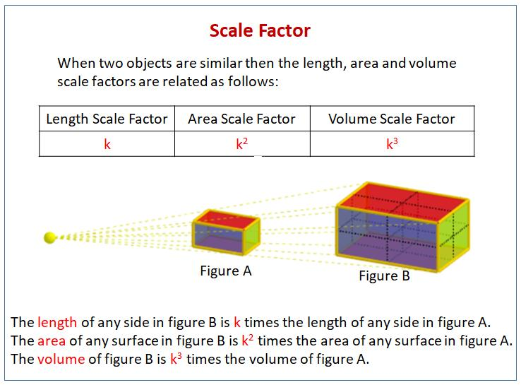
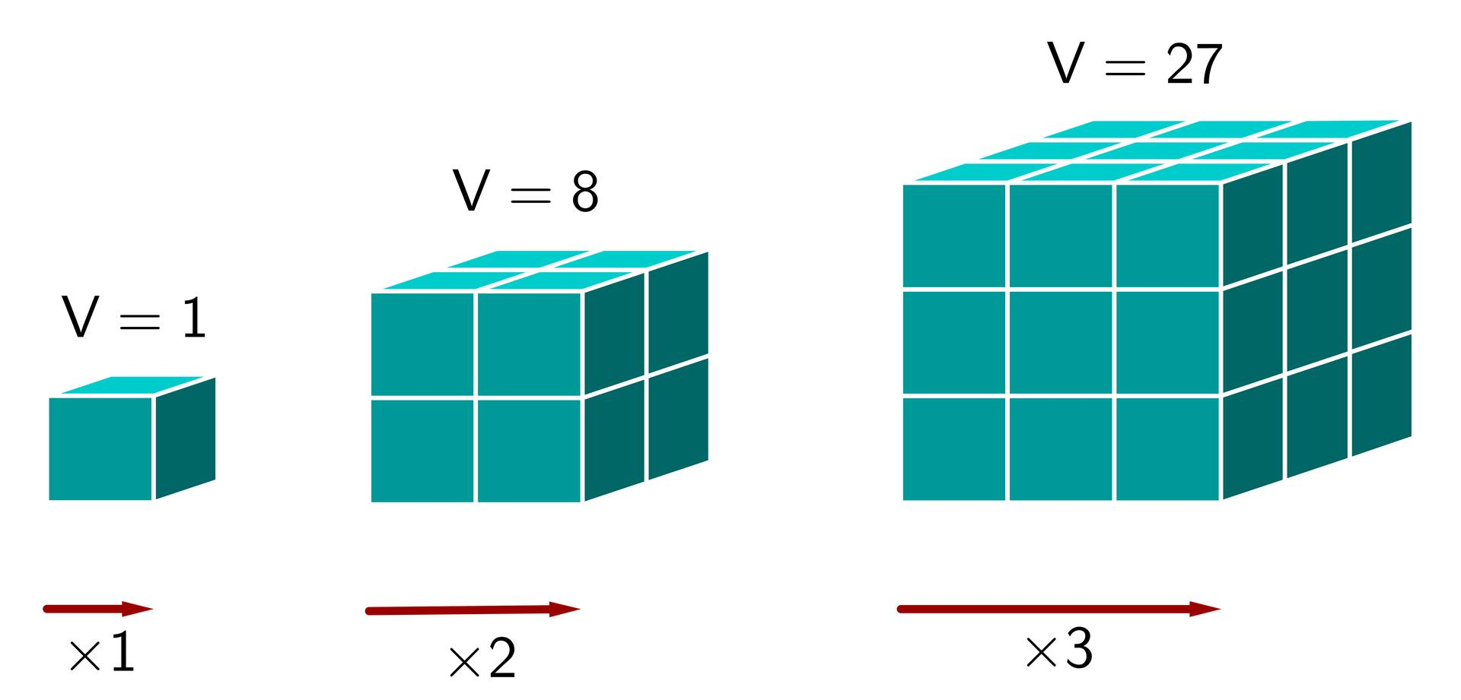
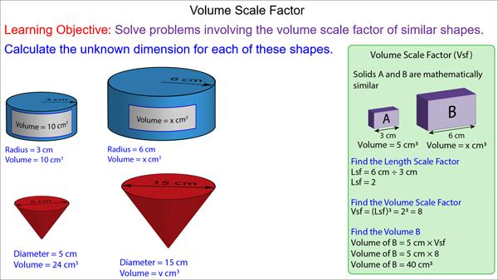

Similarity of Polygons
# Source: AI Source: Provided by: [Data Path: Persons Table -> ID Column: 1, Name_En Column: Motasem Essam] -> From: [ChatGPT] on [7/25/2026]
Two polygons are similar when:
- Corresponding angles are equal.
- Corresponding side lengths are proportional.
- They have the same shape.
For example:
$$ABCD∼EFGH$$
means:
$$∠A=∠E \\ ∠B=∠F \\ ∠C=∠G \\ ∠D=∠H$$
and:
$$\frac{AB}{EF}$$
$$\frac{BC}{FG}$$
$$\frac{CD}{GH}$$
$$\frac{DA}{HE}$$
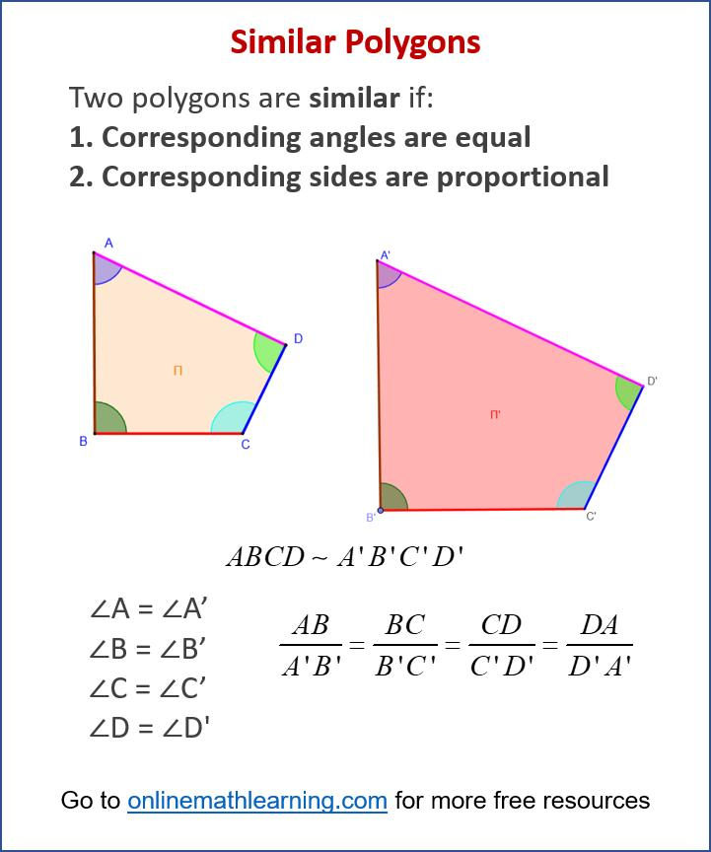
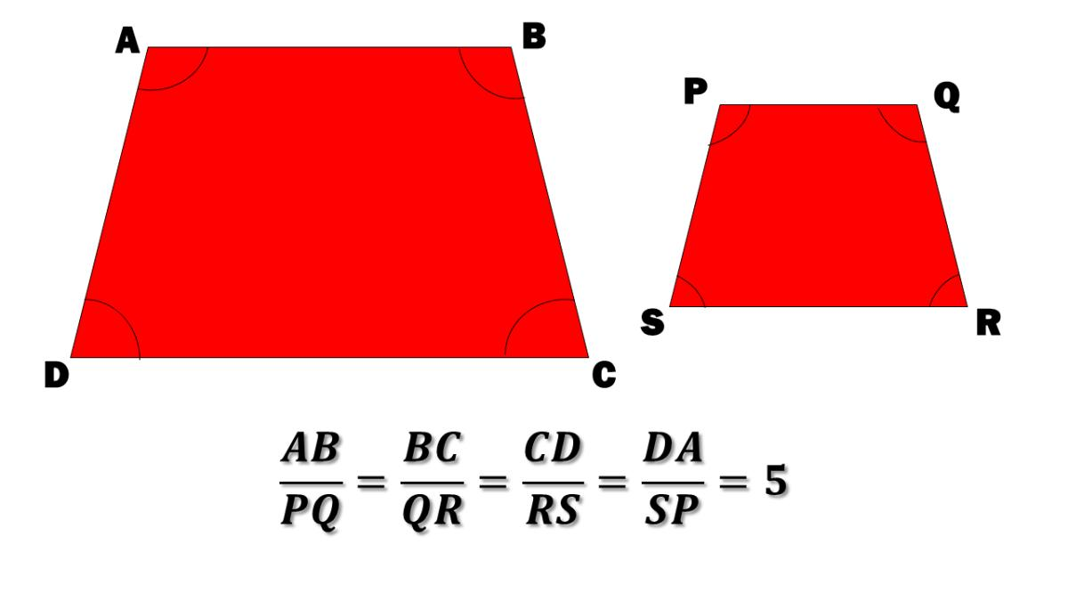
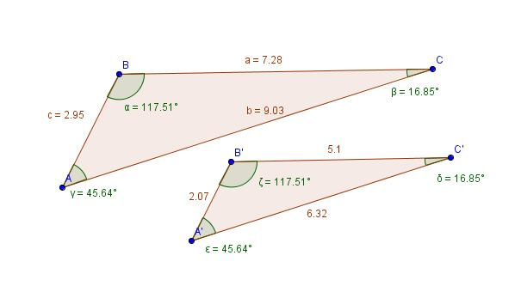
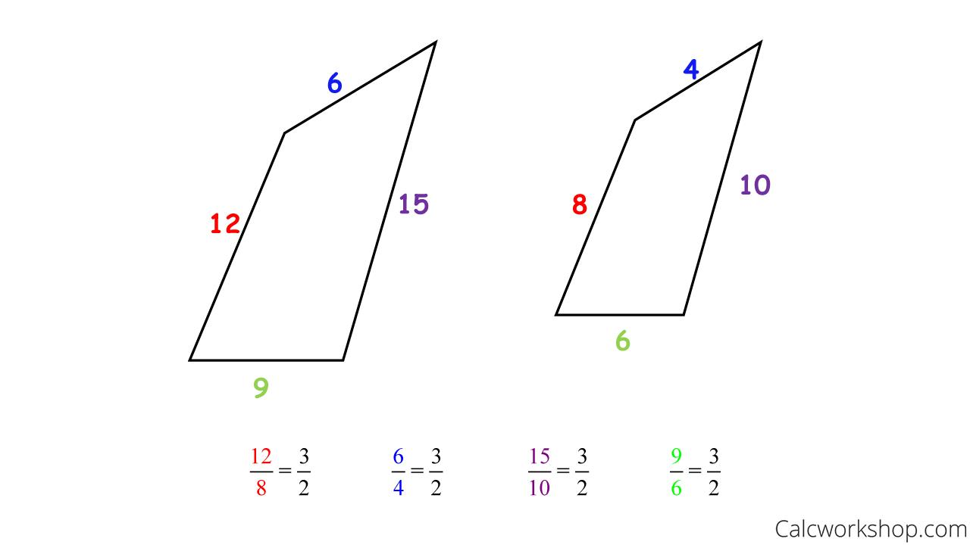

Similarity vs Congruence
# Source: AI Source: Provided by: [Data Path: Persons Table -> ID Column: 1, Name_En Column: Motasem Essam] -> From: [ChatGPT] on [7/25/2026]
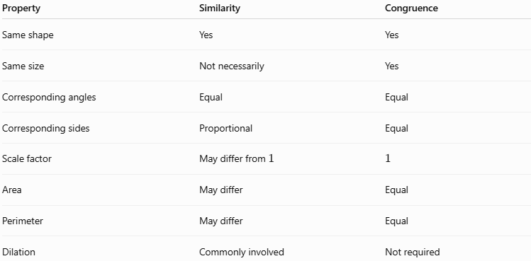
Property | Similarity | Congruence
Same shape | Yes | Yes
Same size | Not necessarily | Yes
Corresponding angles | Equal | Equal
Corresponding sides | Proportional | Equal
Scale factor | May differ from $1$ | $$1$$
Area | May differ | Equal
Perimeter | May differ | Equal
Dilation | Commonly involved | Not required
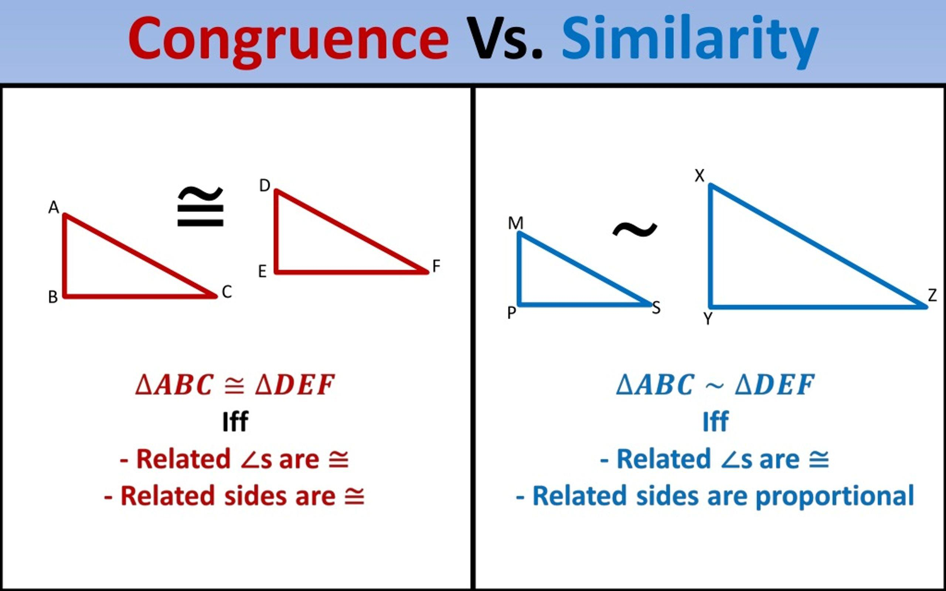
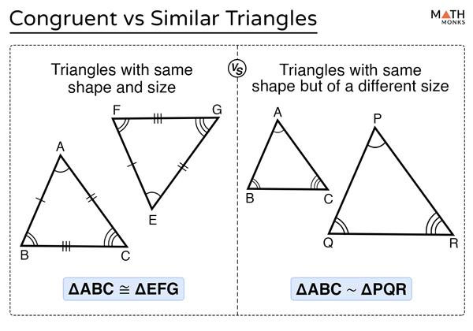
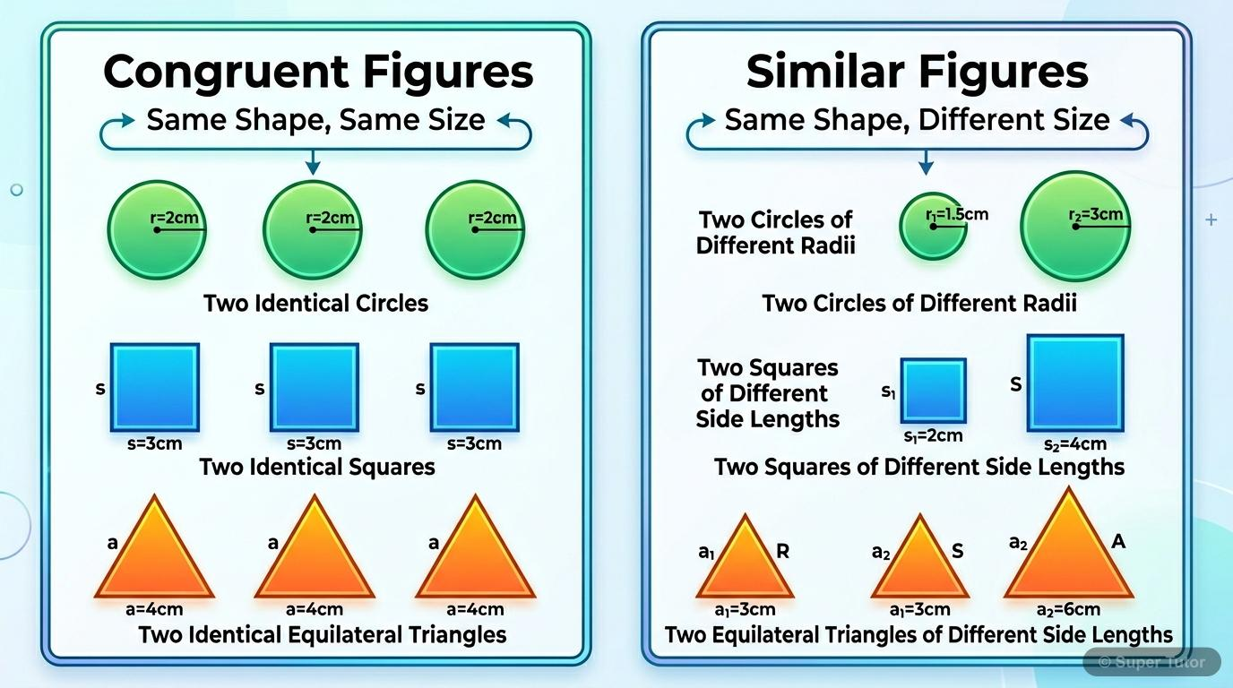
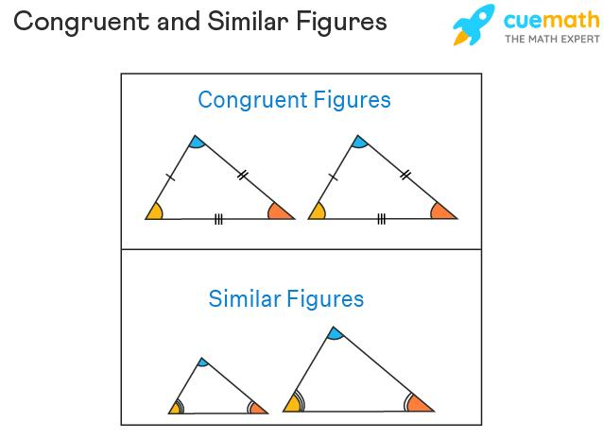
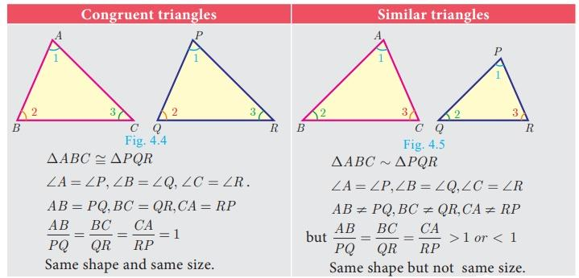

Similarity and Symmetry
# Source: AI Source: Provided by: [Data Path: Persons Table -> ID Column: 1, Name_En Column: Motasem Essam] -> From: [ChatGPT] on [7/25/2026]
Similarity and symmetry are related but represent different concepts.
Similarity compares two or more figures.
Symmetry describes a relationship between parts of the same figure or between a figure and its transformed image.
For example, a reflection of a figure produces an image that is congruent to the original, and therefore also similar.
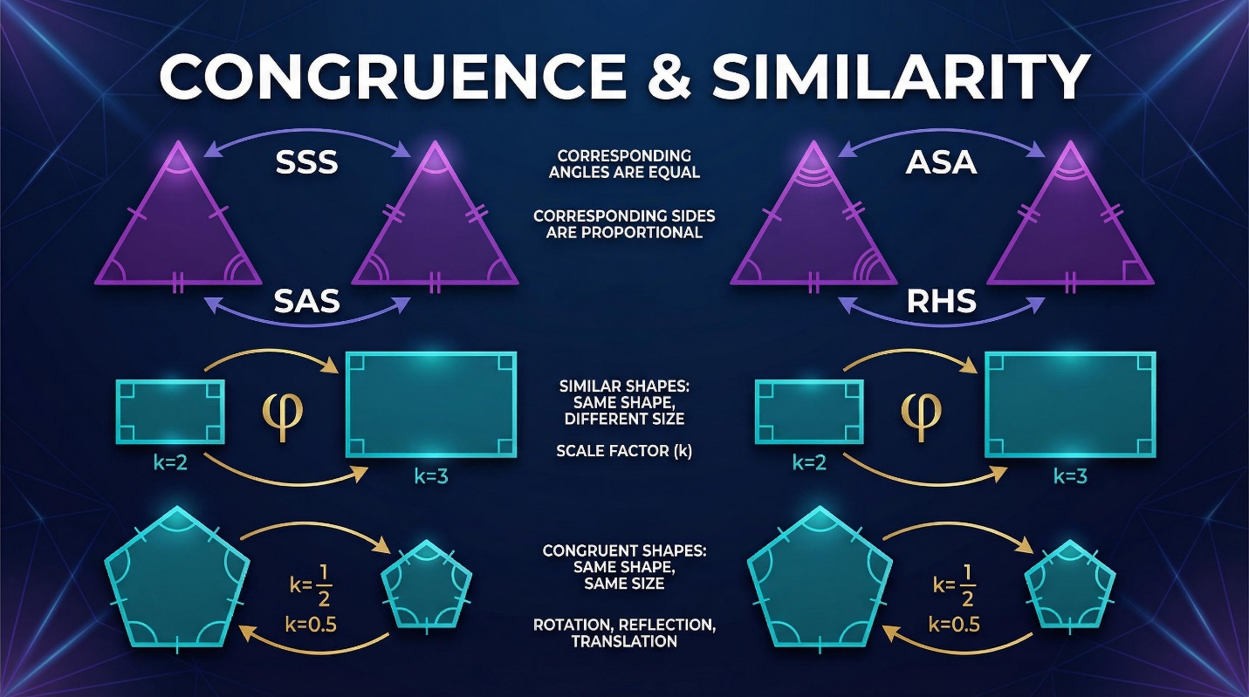
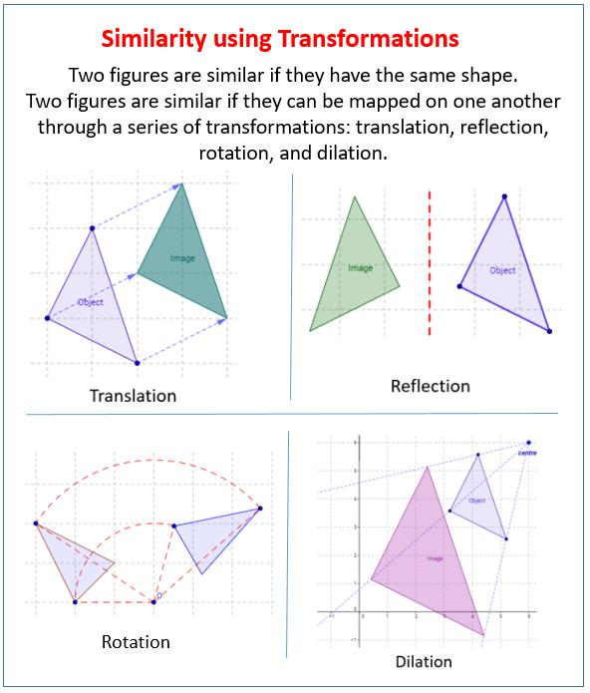
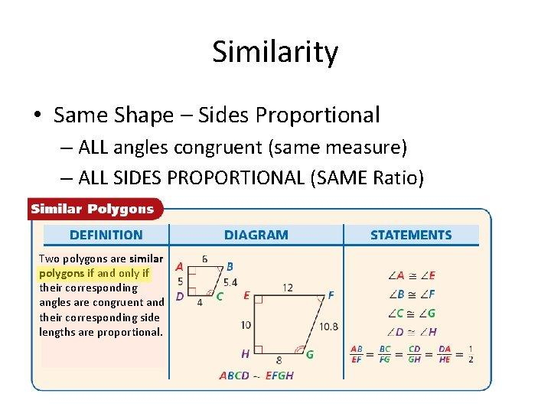

Real-World Examples
# Source: AI Source: Provided by: [Data Path: Persons Table -> ID Column: 1, Name_En Column: Motasem Essam] -> From: [ChatGPT] on [7/25/2026]
Similarity is widely used in real-world situations.
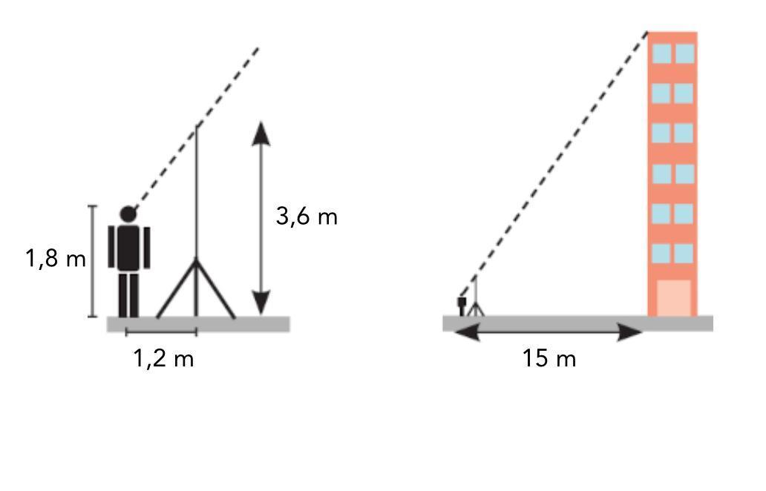
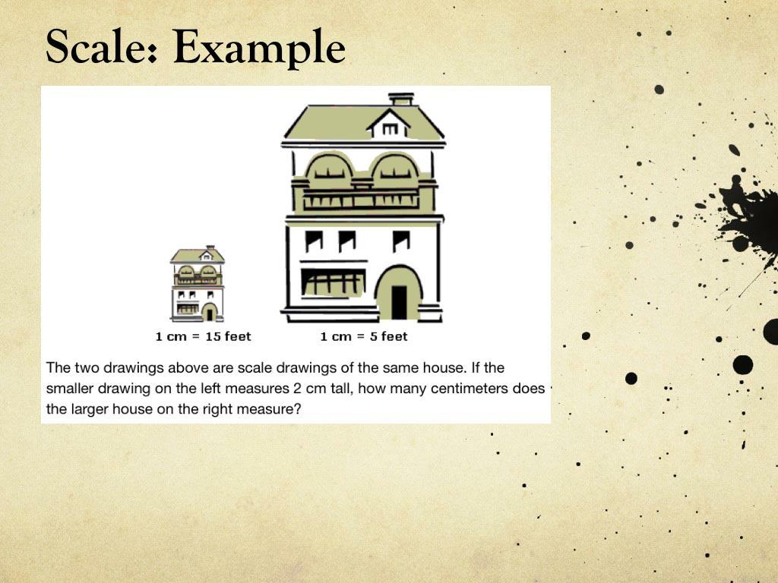
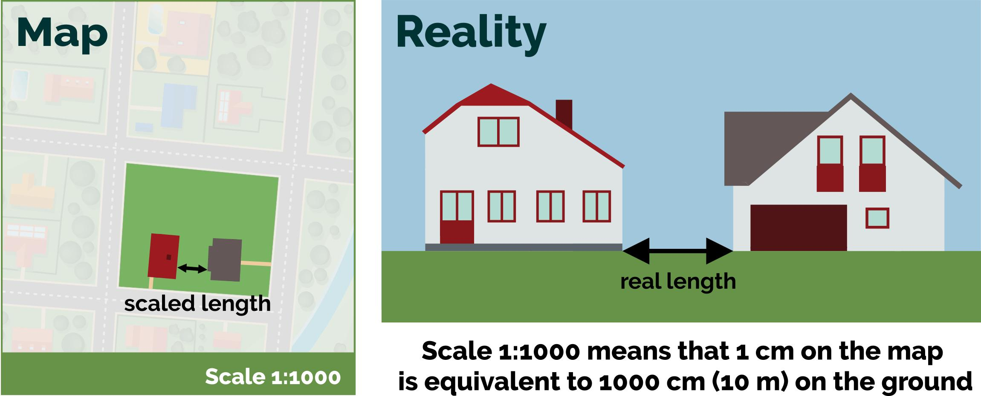
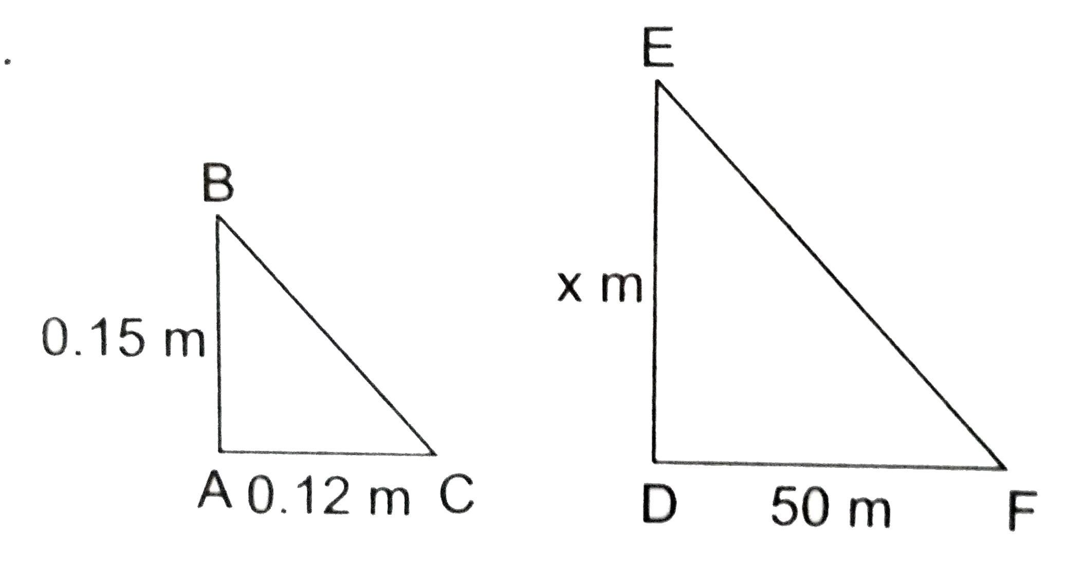
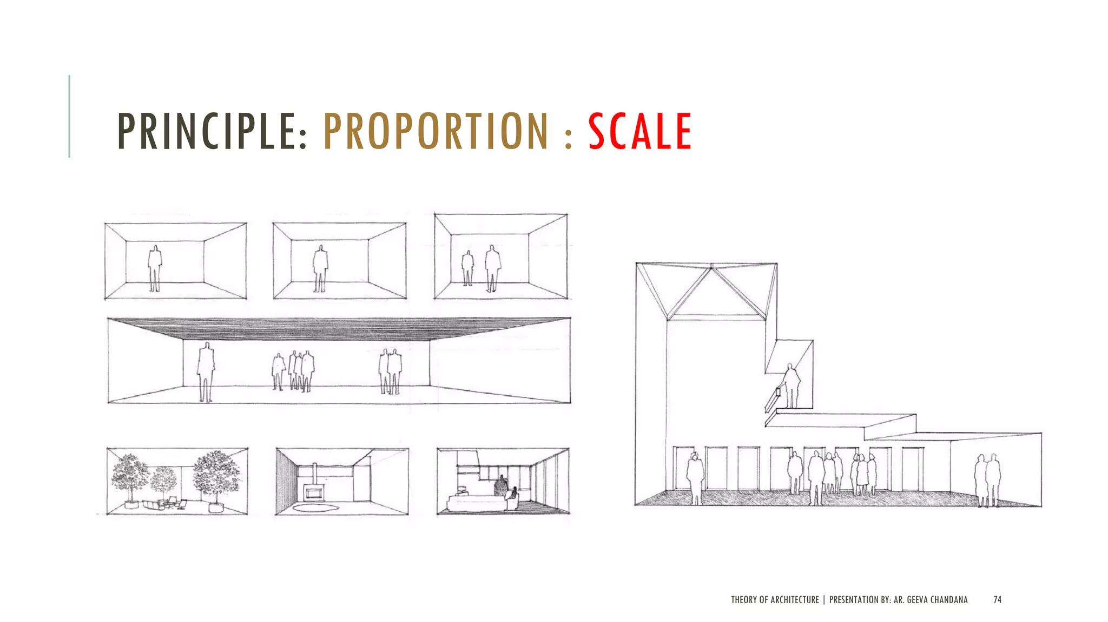
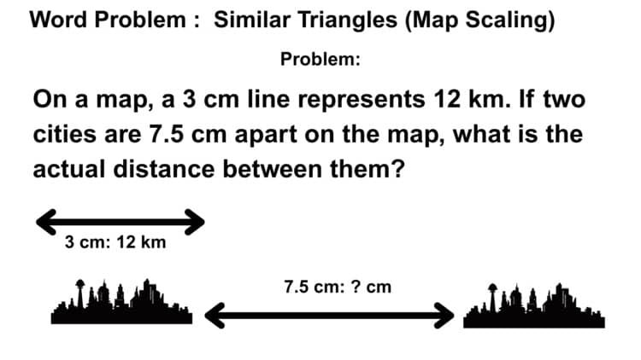
Examples include:
- Maps and scale drawings.
- Architectural plans.
- Engineering drawings.
- Model buildings.
- Photography.
- Computer graphics.
- Measuring heights indirectly.
- Surveying.
- Maps and geographic models.
- Enlarging or reducing images.
Example: Measuring a Building
A surveyor can use similar triangles to determine the height of a building without directly measuring the building.
If two triangles have the same angles, their corresponding sides are proportional.

Applications
# Source: AI Source: Provided by: [Data Path: Persons Table -> ID Column: 1, Name_En Column: Motasem Essam] -> From: [ChatGPT] on [7/25/2026]
Similarity is important in:
- Plane Geometry
- Triangle Geometry
- Coordinate Geometry
- Trigonometry
- Surveying
- Architecture
- Civil Engineering
- Mechanical Engineering
- CAD
- Cartography
- Computer Graphics
- Photography
- Scale Modeling

Advantages
# Source: AI Source: Provided by: [Data Path: Persons Table -> ID Column: 1, Name_En Column: Motasem Essam] -> From: [ChatGPT] on [7/25/2026]
Studying similarity helps to:
- Find unknown lengths.
- Calculate inaccessible distances.
- Create accurate scale drawings.
- Compare geometric figures.
- Understand proportional relationships.
- Solve triangle problems.
- Analyze maps and models.
- Design objects at different scales.
- Understand dilation and enlargement.

Limitations
# Source: AI Source: Provided by: [Data Path: Persons Table -> ID Column: 1, Name_En Column: Motasem Essam] -> From: [ChatGPT] on [7/25/2026]
Similarity:
- Requires corresponding angles to be equal and sides to be proportional.
- Does not mean that two figures have the same size.
- Cannot be established from only one pair of equal sides.
- Requires careful identification of corresponding parts.
- Can become more complex with irregular figures and multiple scale factors.

Mathematical Representation
# Source: AI Source: Provided by: [Data Path: Persons Table -> ID Column: 1, Name_En Column: Motasem Essam] -> From: [ChatGPT] on [7/25/2026]
If two figures $F_{1}$ and $F_{2}$ are similar:
$$\boxed{F_{1}∼F_{2}}$$
Their corresponding angles satisfy:
$$∠A=∠A'$$
and their corresponding lengths satisfy:
$$\frac{AB}{A'B'}=\frac{BC}{B'C'}=\frac{CA}{C'A'}=k$$
where $k$ is the scale factor.

Key Points
# Source: AI Source: Provided by: [Data Path: Persons Table -> ID Column: 1, Name_En Column: Motasem Essam] -> From: [ChatGPT] on [7/25/2026]
- Similarity means same shape but not necessarily the same size.
- The symbol for similarity is:
$$\boxed{∼}$$
- Corresponding angles of similar figures are equal.
- Corresponding sides are proportional.
- The scale factor describes the ratio between corresponding lengths.
- (k>1) produces an enlargement.
- (0<k<1) produces a reduction.
- The main triangle similarity criteria are:
  - AA
  - SSS
  - SAS
- Dilation is closely associated with similarity.
- If the linear scale factor is $k$:
$$\text{Perimeter ratio}=k \\ \text{Area ratio}=k^{2} \\ \text{Volume ratio}=k^{3}$$
- Similarity is widely used in maps, scale drawings, surveying, architecture, engineering, and design.

Conclusion
# Source: AI Source: Provided by: [Data Path: Persons Table -> ID Column: 1, Name_En Column: Motasem Essam] -> From: [ChatGPT] on [7/25/2026]
Similarity is a fundamental type of Geometric Relationship in which two or more figures have the same shape but may have different sizes. Similar figures have equal corresponding angles and proportional corresponding side lengths. The concept is closely connected to scale factors, dilation, proportionality, and triangle similarity criteria such as AA, SSS, and SAS. Similarity provides powerful methods for finding unknown measurements and is widely used in geometry, surveying, architecture, engineering, cartography, CAD, computer graphics, and scale modeling.

